**Cardiff Metropolitan University**

**B.Sc. (Hons) in Business Information Systems**

**Assignment Cover Sheet**

|  |  |  |  |  |  |  |  |  |  |
| --- | --- | --- | --- | --- | --- | --- | --- | --- | --- |
| **Student Details (Student should fill the content)** | | | | | | | | | |
| Name | | | Hashendra Dilan Nawarathna | | | | | | |
| Student ID | | | St20208733 | | | | | | |
| **Scheduled unit details** | | | | | | | | | |
| Unit code | | | CIS6008 | | | | | | |
| Unit title | | | Analytics and Business Intelligence | | | | | | |
| Unit enrolment details | | | Year | | 3 | | | | |
| Study period | | 2023 | | | | |
| Lecturer | | | Assignment prepared by Induranga De Silva | | | | | | |
| Mode of delivery | | | Full Time | | | | | | |
| **Assignment Details** | | | | | | | | | |
| Nature of the Assessment | | | Coursework (a report) | | | | | | |
| Topic of the Case Study | | | Application of statistical and geospatial business analytics tools, techniques and methodologies to generate business intelligence essential for informed decision making in Power and Renewable Energy sector credible, efficient and effective informed decision making in Sri Lanka. | | | | | | |
| Learning Outcomes covered | | | LO2, LO3, LO4 | | | | | | |
| Word count | | | 3200(report) | | | | | | |
| Due date / Time | | | 31st August 2023 | | | | | | |
| Extension granted? | | | Yes | No | Extension Date | | | |  |
| Is this a resubmission? | | | Yes | No | Resubmission Date | | | |  |
| **Declaration** | | | | | | | | | |
| I certify that the attached material is my original work. No other person’s work or ideas have been used without acknowledgement. Except where I have clearly stated that I have used some of this material elsewhere, I have not presented it for examination / assessment in any other course or unit at this or any other institution | | | | | | | | | |
| Name/Signature | | | Dilan | | | Date | | | 04/09 |
| **Submission** | | | | | | | | | |
| Return to: | | |  | | | | | | |
| **Result** | | | | | | | | | |
| Marks by 1st Assessor |  | Name & Signature of the 1st Assessor | | | | |  | **Agreed Mark** | |
| Marks by2nd Assessor |  | Name & Signature of the 2nd Assessor | | | | |  |
| Comments on the Agreed mark |  | | | | | | | | |

**CMU B.Sc. (HONS) BIS - ASSIGNMENT FEEDBACK SHEET –ICBT CAMPUS**

|  |  |  |  |  |  |  |  |  |
| --- | --- | --- | --- | --- | --- | --- | --- | --- |
| **STUDENT NAME: Dilan Nawarathna** | | | | | | **STUDENT NUMBER: st20208733** | | |
| **Module Number & Title**: Analytics and Business Intelligence | | | | | | **Semester: II** | | |
| **Assignment Type & Title**: Coursework  Application of statistical and geospatial business analytics tools, techniques, and methodologies to generate business intelligence essential for informed decision making in Power and Renewable Energy sector credible, efficient, and effective informed decision making in Sri Lanka. | | | | | | | | |
| **For student use:** Critical feedback on the individual progression towards achieving the assignment outcomes | | | | | | | | |
|  | | | | | | | | |
| **For the Assessors’ feedback**  **Indicate the Task number strength and Weaknesses and the marks for each task** | | | | | | | | |
| Task No/Question No | | Strengths (1st Assessor) | | | | | | Strengths (2nd Assessor) |
| **Task No / Question No** | | Weaknesses (1st Assessor) | | | | | | Weaknesses (2nd Assessor) |
| **Areas for future improvement** | | | | | | | | |
| Comments by 1st Assessor | | | | | | | | Comments by 2nd Assessor |
| **Marks** | | | | | | | | |
| **Task /Question No** | **Marks by 1st Assessor** | | **Marks by 2nd Assessor** | | **Marks by IV (if any)** | | **IV comments (If Any)** | |
|  |  | |  | |  | |  | |
|  |  | |  | |  | |
|  |  | |  | |  | |
| Total Marks |  | |  | |  | |
| Name and the Signature of the 1st Assessor | | | |  | | Date: | |  |
| Name & Signature of the 2ndAssessor: | | | |  | | Date: | |  |
| Name & Signature of the IV: (If any) | | | |  | | Date: | |  |

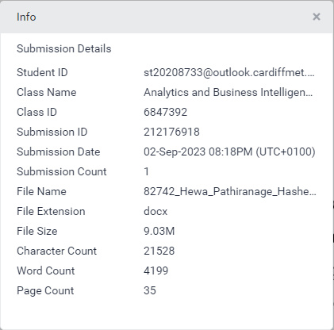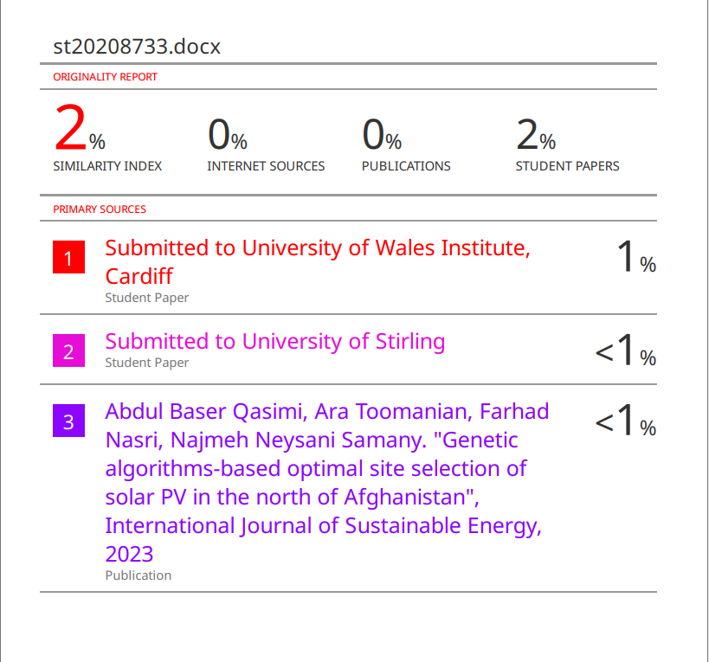

# AKNOWLAGEMENT

The students of BSc in Computing & Software Engineering, batch 10, express their deep gratitude to those who have played pivotal roles in their academic journey. They extend heartfelt thanks to Mr. Asanka Dinesh, their dedicated lecturer in Analytics and Business Intelligence, for his unwavering support, patience, and guidance. They also appreciate the invaluable assistance provided by their seniors, recognizing the importance of peer support in completing assignments and projects. The students extend gratitude to the entire ICBT management and staff for fostering a friendly and welcoming environment. Lastly, they convey heartfelt thanks to their families for their unwavering moral support throughout their academic journey. These acknowledgments underscore the collective efforts and support that have shaped their academic achievements.

# EXECATIVE SUMMARY

This assignment focuses on assessing students' capabilities in business analysis utilizing Statistical and Geographic Information Systems (GIS) tools, techniques, and methodologies. The objective is to extract valuable insights that can inform decision-making in both private and government sectors, reducing ambiguity and uncertainty. The tasks encompass a wide range of analyses and visualizations, starting with the examination of data related to building cooling and structural factors in Sri Lanka's renewable energy sector. This data is analyzed using statistical and business analytics tools like R, R-Studio, and R-Commander, with findings discussed. Subsequent tasks involve the creation of informative maps, such as one visualizing suitable land for Wind Power development and another illustrating potential areas for Solar Power facilities. Additionally, students are required to develop a PostgreSQL Geospatial Database to analyze gasoline and diesel usage and create thematic maps, among other tasks. The assignment culminates in the selection of a suitable land location for a Regional Research Center for Renewable Energy in Kandy, considering various factors and evaluating soil quality. Overall, these tasks challenge students to apply their skills to real-world scenarios in the renewable energy sector, fostering critical thinking and data-driven decision-making abilities.

# TABLE OF CONTENT

AKNOWLAGEMENT V

EXECATIVE SUMMARY VI

TABLE OF CONTENT VII

LIST OF FIGUERS IX

LIST OF TABLES XI

ABSTRACTION XII

ABBRIVIATION XIII

INTRODUCTION 1

Question 1 2

Analyzing the energy_efficiency_data.csv data file 3

1.1.1. Import the data set. 3

1.1.2. Search Categorical and Continuous values. 4

1.1.3. Cooling Load data distribution 4

1.1.4. Scatter plot 5

1.1.5. Finding relationships 7

Question 2 10

Summary Of the lm () function 10

2.1. Cooling_Load and Heating_Load Relationship 10

2.1.1. Summary Statistic for lm () Function 10

2.2. Cooling_Load and Glazing_Area Relationship 11

2.2.1. Summary Statistic for lm () Function 11

2.3. Cooling_Load and Overall_Height Relationship 12

2.3.1. Summary Statistic for lm () Function 12

2.4. Cooling_Load and Relative_Compactness Relationship 13

2.4.1. Summary Statistic for lm () Function 13

Question 3 14

Question 4 20

Question 5 24

Question 6 26

Question 7 30

Question 8 35

CONCLUTION 37

GANTT CHART I

REFERENCERS II

APENDIX III

# LIST OF FIGUERS

Figure 1.1.1.1.Sample data set screenshot 2

Figure 1.1.1.2. Data dictionaries of data set 3

Figure 1.1.1.1.Sample code 1 3

Figure 1.1.1.2.Sample data set in R-studio 4

Figure 1.1.3.1.Bell curve of cooling load data set 5

Figure 1.1.4.1.Scatter plot 5

Figure 1.1.4.2.Linear regression 6

Figure 1.1.4.3.Summary of the data set 6

Figure 1.1.5.1.Peason's correlation testing 1 7

Figure 1.1.5.2.Peason's correlation testing 2 8

Figure 1.1.5.3.Peason's correlation testing 3 8

Figure 1.1.5.4.Peason's correlation testing 4 9

Figure 1.1.5.1.lm() function 1 10

Figure 2.1.1.1.Summary statistic of lm() function 1 10

Figure 2.1.1.1lm() function 2 11

Figure 2.2.1.1.Summary statistic of lm() function 2 11

Figure 2.2.1.1lm() function 3 12

Figure 2.3.1.1.Summary statistic of lm() function 3 12

Figure 2.3.1.1.lm() function 4 13

Figure 2.4.1.1.Summary statistic of lm () function 4 13

Figure 2.4.1.1.sampledata set for question C 14

Figure 2.4.1.2.LAnd availability for wind power in Sri Lanka 15

Figure 2.4.1.3.Color pellet legend 16

Figure 2.4.1.4.Sample dataset screenshot 17

Figure 2.4.1.5.Protential land for wind power development 18

Figure 2.4.1.1.sampledata set for question D 20

Figure 2.4.1.2.Protential land for sola power development 21

Figure 2.4.1.3.Color pallet legend 22

Figure 2.4.1.4sampledata set for question D 23

Figure 2.4.1.1.Digitalization of solar power plant 24

Figure 2.4.1.2.Digitalization of solar power plant 2 25

Figure 2.4.1.1.sampledata set for question E 26

Figure 2.4.1.2.monthly consumption of the gasoline and diesel by district 27

Figure 2.4.1.3.Color pallet legend 28

Figure 2.4.1.4.Mean of gasoline and diesel in month using Pie chart 29

Figure 2.4.1.1.Suitable location for renewable energy generation 32

Figure 2.4.1.2.Suitable locations for sola power 33

Figure 2.4.1.3.Suitable location for wind power 34

Figure 2.4.1.1.Suitable land for Regional research center in Kandy 35

Figure 2.4.1.2.Suitable land for Regional research center in Kandy 36

# LIST OF TABLES

Table 1.1.2.1.Catagorical and Continuous value table 4

Table 1.1.5.1.Hypothesis 1 7

Table 1.1.5.2.Hypothesis 2 7

Table 1.1.5.3.Hypothesis 3 8

Table 1.1.5.4.Hypothesis 4 9

Table 2.4.1.1.Answer table for area 36

# ABSTRACTION

This content discusses the critical role of electricity in the modern world, driven by increasing global demand due to population growth. It highlights the division of power generation into renewable and non-renewable sources, with a growing emphasis on renewable energy due to the depletion of non-renewable resources.

The focus of the content is on an assignment that analyzes factors essential for reducing electricity consumption in cooling buildings. It utilizes data to explore ways to save energy when cooling buildings using methods such as air conditioning and electric fans.

The narrative then shifts to the development of renewable energy in Sri Lanka, addressing various challenges. These include creating district-based maps for solar electricity development, mapping existing solar power plants, digitizing an area with features like forests and roads, and discussing fuel station expansion and fuel distribution across districts.

Additionally, the content touches on identifying suitable locations for wind and solar energy generation in Sri Lanka and finding suitable land for a regional research center for renewable energy in Kandy.

In summary, the content provides a comprehensive overview of the significance of renewable energy development in Sri Lanka and offers insights into strategies for both energy conservation in building cooling and sustainable energy generation.

# ABBRIVIATION

|  |  |
| --- | --- |
| DAM | Digitized Area Map |
| DEA | Data Analysis and Visualization for Energy Efficiency |
| DSM | Development of Statistical Models |
| REGM | Renewable Energy Generation Locations Map |
| SPDM | Solar Power Development Map |
| WPDM | Wind Power Development Map |

# INTRODUCTION

Today's world has become a world of development with electricity. It is a fact that everyone knows that there is no existence in a world without electricity. Electricity consumption is gradually increasing with the increase in population size. However, during power generation, grants are created under two methods. The two types are mentioned as renewable and non-renewable. However, due to the depletion of non-renewable energy, people are turning to renewable energy(colorlib, 2023).

Efforts are also made to save the existing power along with turning to other energy sources. There, in questions ‘A’ and ‘B’ of the assignment provided to analyze the factors needed to reduce the electricity used for cooling the buildings. Based on the data file provided there, the factors that are required to maintain the cooling of a building will be analyzed. Based on these factors, it will be possible to reduce the cooling of the building by using AC machines or electric fans.

The development of renewable energy in Sri Lanka will be discussed in the rest of the issues. Regarding the 'C' problem, a map classified into districts according to the amount of land suitable for the development of Sulan electricity will be created. Also, by problem 'D', a map is created based on total capacity, total estimated energy and total area based on the electricity produced by the existing solar power plants. Also, digitization of the area provided in problem 'E' is done. Forests, trees, roads etc. are marked on the map.

The fuel station in Sri Lanka is discussed in problem 'f'. Namely, the expansion of the fuel stations in the districts as well as the information about the diesel and petrol in relation to the respective districts will be mapped here. Also, in the 'G' problem, there is a map showing suitable locations for creating wind energy, solar energy, etc. in Sri Lanka. Also, in the 'H' problem mentioned as the last problem, finding suitable land for the new development of a regional research center for renewable energy in Kandy and searching for information about that area is done in that problem. At the end of this pamphlet, you will be able to get an understanding of the renewable energy products and their suitable areas, as well as the things that should be done for cooling during the construction of a building.

# 

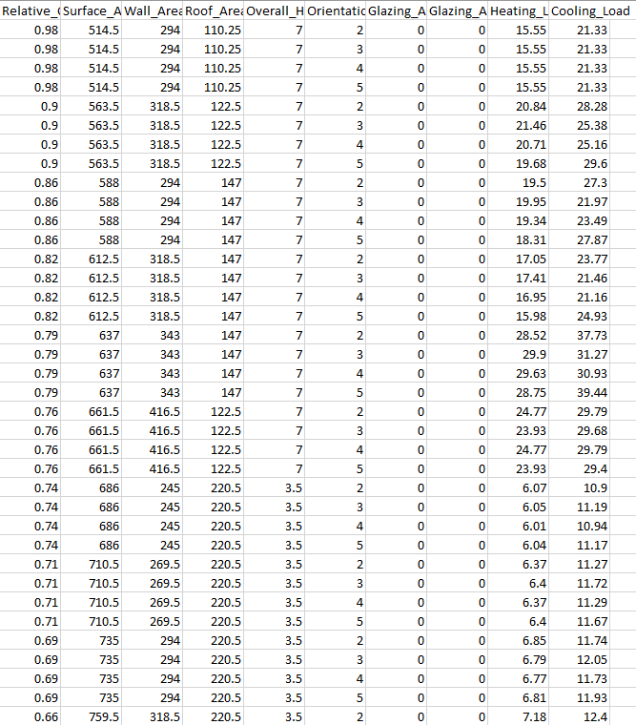The Ministry of Power and Renewable Energy is conducting various research studies related to the electricity generation required in the country using local as well as global data. Residential and commercial refrigeration can be identified as a major source of electricity consumption. Therefore, to reduce the consumption of electricity, attention is focused on the construction of buildings to keep the cooling of the buildings. A dataset named “*energy_efficiency_data.csv”* is provided and its data dictionary captures potential relationships between building cooling and associated building structural factors related to building shapes.

Figure ..Sample data set screenshot

Below are screenshots of a dataset and its data dictionary.

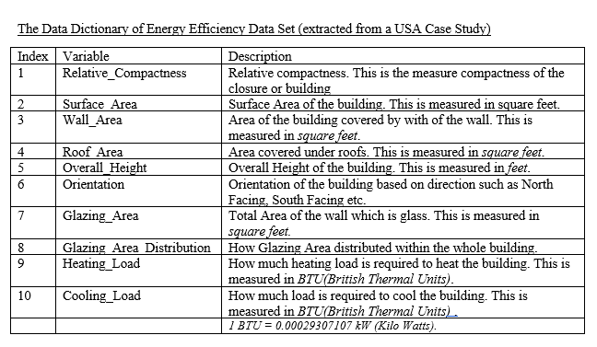

Figure .. Data dictionaries of data set

## Analyzing the energy_efficiency_data.csv data file

#### Import the data set.

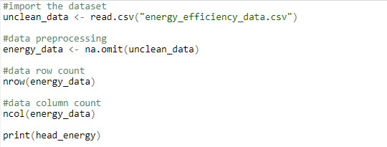 First the data file is uploaded to R-Studio. The data file is first cleaned for data analysis. There the null values in the data file are removed. As mentioned here, it consists of 768 rows and 10 columns. Then the display of the data file is clearly shown by the following screenshot

Figure ..Sample code 1

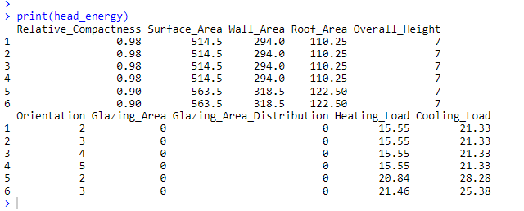

Figure ..Sample data set in R-studio

#### Search Categorical and Continuous values.

Categorical values and continuous separation are important in data theft analysis. The reserved data is categorized below.

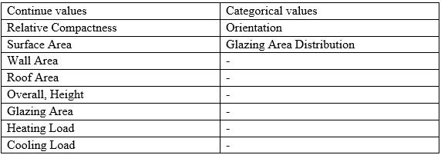

Table ..Catagorical and Continuous value table

#### Cooling Load data distribution

Bell curves related to the 'Coolant Load' column can be seen in the screenshot below. where the distribution of the data file is shown with respect to that column and the standard deviation of the data file is used to construct it. The distribution of this data file consists of two peaks and is called a multivariate distribution. The analysis is performed assuming that this data file is bell curved.

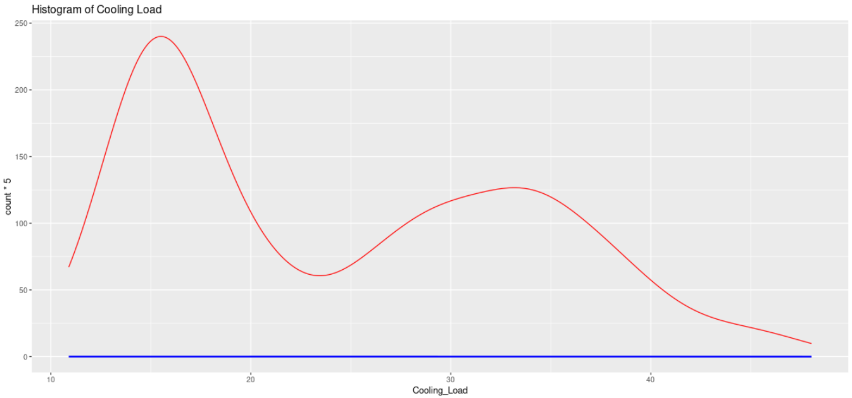

Figure ..Bell curve of cooling load data set

#### Scatter plot

A scatter plot is used as a data visualization used in statistics and data analysis to show the relationship of variables. However, categorical data is not used here, and continuous data is used. The data taken from the war file contains 'Orientation' and 'Glazing Area Distribution' as categorical data, so it is not used to create a scatter plot. Below is the scatter plot created for continuous data.

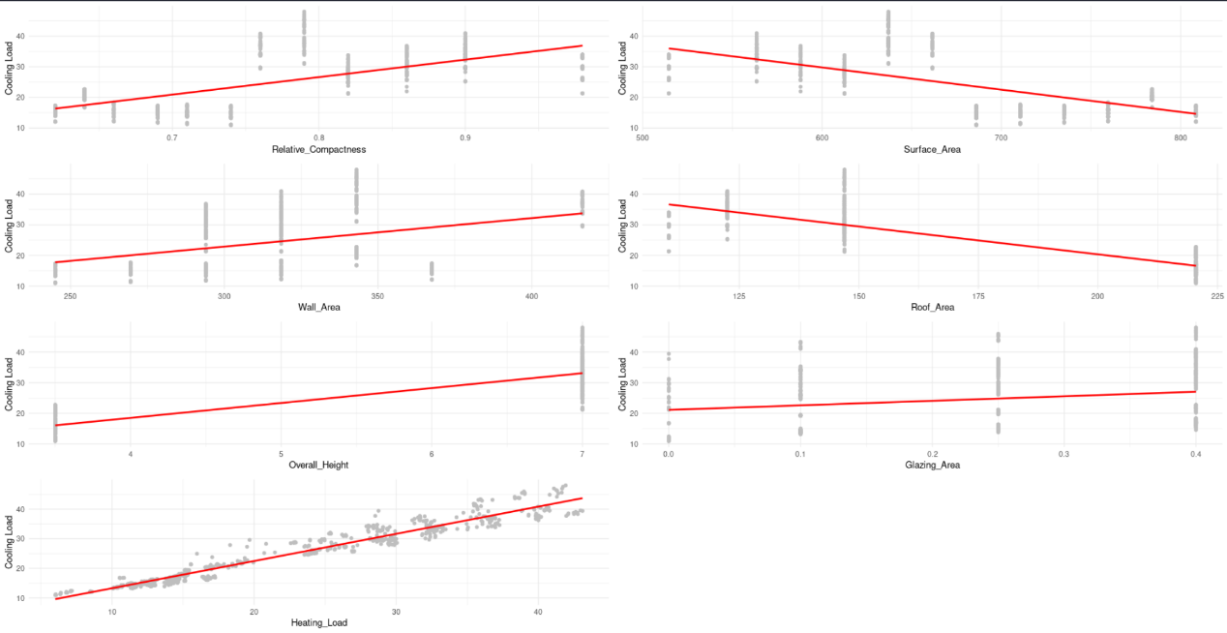

Figure ..Scatter plot

This scatter plot is used to study the correlations between Cooling_Load and other variables. In this regard, a good relationship between the Heating Load and the Cooling_Load can be seen from the scatter plot collections. But it is not seen that there is a good relationship with other factors. However, here the correlation matrix and summary are used to get accurate information about the correlation data.

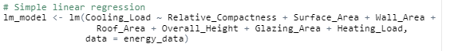

Figure ..Linear regression

Above is the model designed to examine the relationship between Cooling_Load and other variables. However, based on this model, the analysis of the relationship between Cooling_Load and each of the variables is given below.

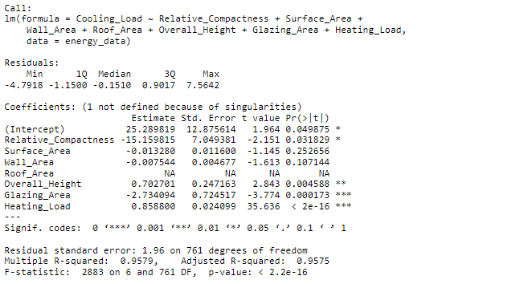

Figure ..Summary of the data set

The summary of the linear regression model is used to get a clear description of the graphs displayed by the scatter plot. Based on the scatter plot drawn above, it was assumed that there is a relationship between Cooling_Load and Heating Load. Also, the assumption was confirmed by this. However, according to the data obtained here, it can be seen that there is a relationship between Cooling_Load and Glazing_Area, Overall_Height, Relative_Compactness. According to the information obtained here, it is clearly seen by the p-value that there is a very good relationship between Cooling_Load and Heating Load.

#### Finding relationships

##### Cooling_Load and Heating_Load Relationship

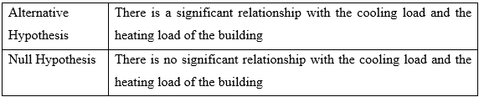

Table ..Hypothesis 1

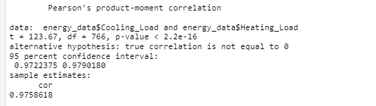

Figure ..Peason's correlation testing 1

Considering Cooling_Load and Heating_Load, p-value = 2.2e-16 is obtained, and the value is less than 0.05, so it seems that there is a very good relationship. Therefore, null hypothesis is removed here and seems to be very well related.

##### Cooling_Load and Glazing_Area Relationship

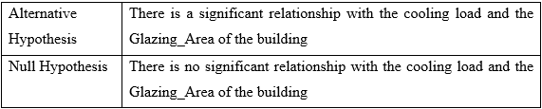

Table ..Hypothesis 2

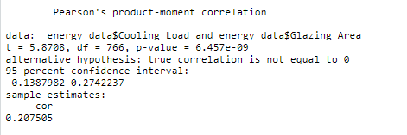

Figure ..Peason's correlation testing 2

Regarding Cooling_Load and Glazing Area, p-value = 6.457e-09 and the value is less than 0.05, so it seems that there is a good relationship between Cooling_Load and Glazing Area. Therefore, the null hypothesis is rejected, and the Alternative Hypothesis is confirmed to be correct.

##### Cooling_Load and Overall_Height Relationship

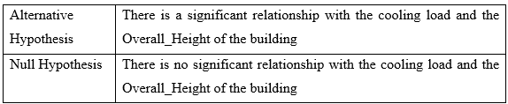

Table ..Hypothesis 3

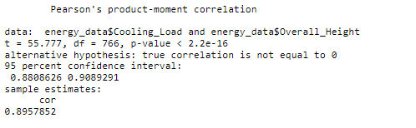

Figure ..Peason's correlation testing 3.

Considering Cooling_Load and Overall_Height, p-value = 2.2e-16 and the value is less than 0.05, so it seems that there is a good relationship between Cooling_Load and Overall_Height. Therefore, the null hypothesis is rejected, and the Alternative Hypothesis is confirmed to be correct.

##### Cooling_Load and Relative_Compactness Relationship

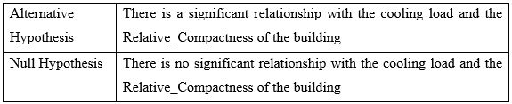

Table ..Hypothesis 4

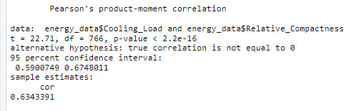

Figure ..Peason's correlation testing 4.

Considering Cooling_Load and Relative_Compactness, p-value = 2.2e-16 and the value is less than 0.05, so it seems that there is a good relationship between Cooling_Load and Relative_Compactness. Therefore, the null hypothesis is rejected, and the Alternative Hypothesis is confirmed to be correct.

# 

## Summary Of the lm () function



### Cooling_Load and Heating_Load Relationship

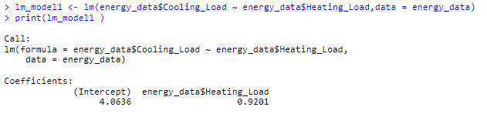

Figure ..lm() function 1



#### Summary Statistic for lm () Function

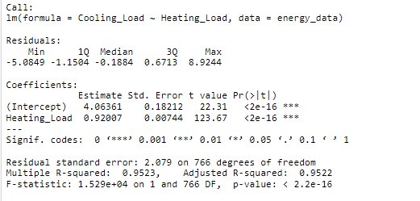

Figure ..Summary statistic of lm () function 1

Considering the relationship between Cooling_Load and Heating_Load, a very high correlation is obtained as obtained above. It seems that there is a good relationship by getting a very small value of 2.2e-16 as p-value. Also, there is a high correlation between Heating_Load and other factors.

### Cooling_Load and Glazing_Area Relationship

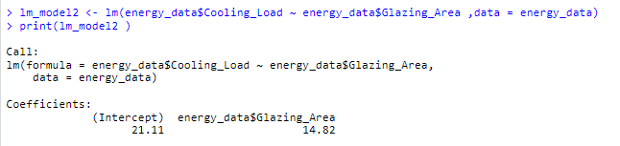

Figure .lm () function 2



#### Summary Statistic for lm () Function

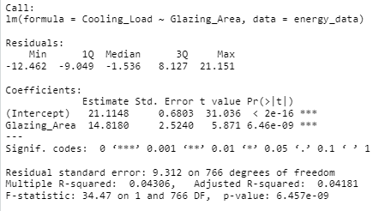

Figure ..Summary statistic of lm () function 2

Considering the relationship between Cooling_Load and Glazing_Area, a relationship can be seen as obtained above. There it seems that there is a relationship by getting a value of 6.457e-09 as p-value. According to the p-value here, it appears that there is a relationship.

### Cooling_Load and Overall_Height Relationship

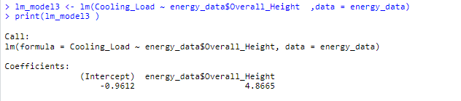

Figure .lm () function 3



#### Summary Statistic for lm () Function

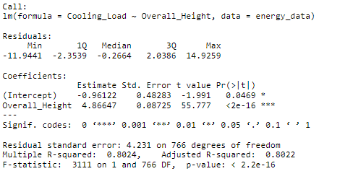

Figure ..Summary statistic of lm () function 3

Considering the relationship between Cooling_Load and Overall_Height, a relationship can be seen as obtained above. There it seems that there is a relationship by getting a value of 2.2e-16 as p-value. According to the p-value here, it appears that there is a relationship.

### Cooling_Load and Relative_Compactness Relationship

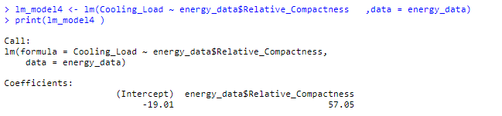

Figure ..lm() function 4



#### Summary Statistic for lm () Function

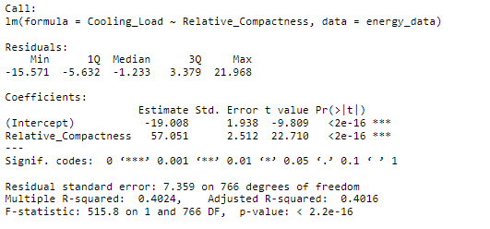

Figure ..Summary statistic of lm () function 4

Considering the relationship between Cooling_Load and Relative_Compactness, a relationship can be seen as obtained above. There it seems that there is a relationship by getting a value of 2.2e-16 as p-value. According to the p-value here, it appears that there is a relationship.

# 

In today's world, people are focusing on the development of regenerative energy. Wind energy can be seen as one sector there. In this work, we are currently looking for viable land for wind energy development in Sri Lanka. Thus, the amount of viable land is calculated according to the district and displayed in a map of Sri Lanka(colorlib, 2023).

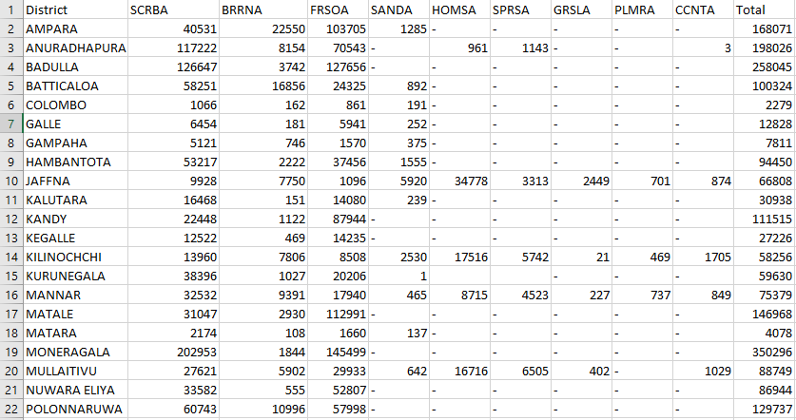To accomplish this task, the data set "***SLWindPowerLand_21_23.csv***" was created containing all the information in Table 7.1 of the "Renewable Energy Development Plan 2021-2026" report published by the Sri Lanka Sustainable Energy Authority. A screenshot of the created file is shown below(Rodrigo, 2022).

Figure ..sampledata set for question C

Below is a map of Sri Lanka with areas suitable for wind power development on the map using the "SLWindPowerLand_21_23.csv" dataset.

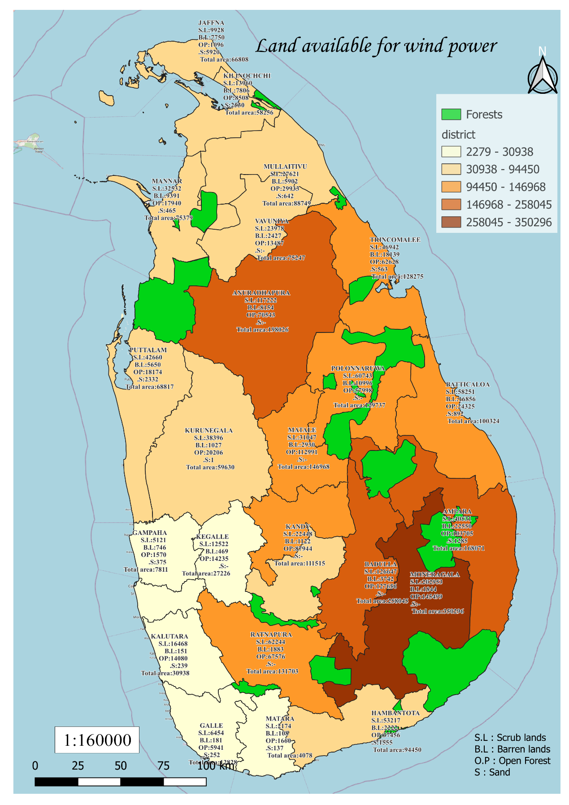

Figure ..LAnd availability for wind power in Sri Lanka

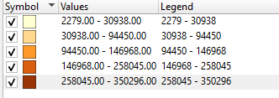Above is a map that visualizes information about potential land, separated by districts in Sri Lanka using the "**SLWindPowerLand_21_23.csv**" data set noted above. In this map they are displayed in 5 colors according to the values of hectares of viable land (ha) when showing them as districts. The kangas used there, and the corresponding colors are given below. Also, the existing forest areas are shown in green color on the map.

Figure ..Color pellet legend

According to the map created here, the dark color (brown) is the district that contains a large amount of viable land for solar energy production. It can also be seen that the amount of viable land available in those districts also decreases depending on the size of the selection. The least i.e., white indicates the district with the least viable land for wind power generation in Sri Lanka(Rodrigo, 2022).

As I have shown the map, a lot of viable land for wind energy development in Sri Lanka has been included in Monaragala district. This area is mentioned as 350296 hectares. Also, Badulla, Anuradhapura, and Ampara districts can be seen as districts with viable land. According to the map, less viable land can be seen in the districts oriented towards the South-East and West directions. Among them, the two least viable lands in Colombo district were taken. The amount is stated as 2279 hectares. Also, Kegalle, Galle, Gampaha and Matara can be taken as other districts with minimum land. Some of the mentioned areas and the amount of land in those areas are given below.

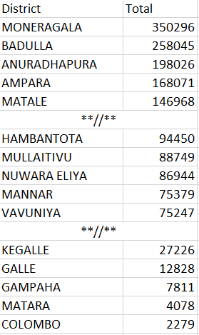

Figure ..Sample dataset screenshot

In order to obtain the amount of land mentioned above, it is important to find out which type of land is suitable for this in those districts. For this, using "**SLWindPowerLand_21_23.csv**", the pie chart was used to determine what type of area conditions the Sri Lanka map is district wise. Here, the amount of scrub land, barren land, open forest, and sand in the district will be displayed.

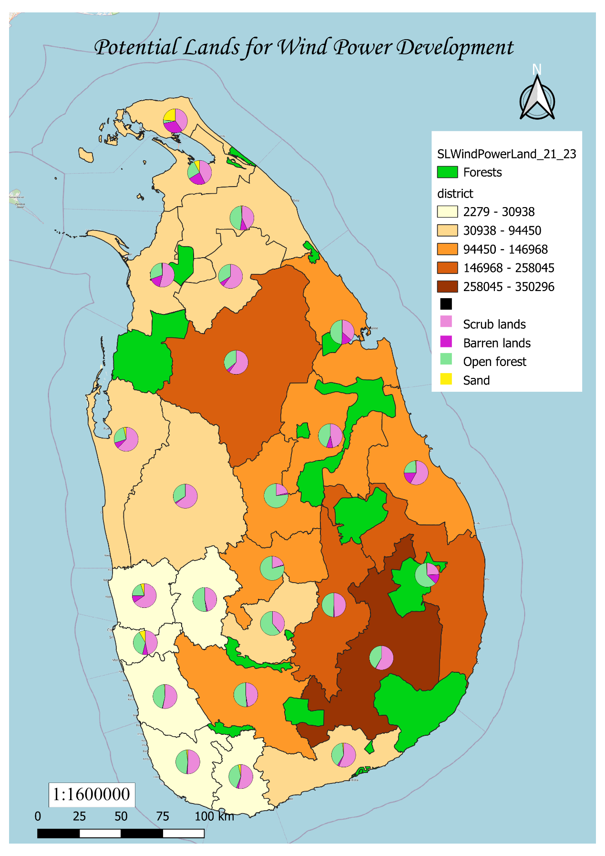

Figure ..Protential land for wind power development

By including the pie charts in the table, the map has been given a good bar. We know that most of the viable land can be seen in Monaragala district. According to the pie chart contained in the above map, about 60% percentage of scrubland (2002953ha) of viable land for producing solar energy can be seen in Monaragala district. Also, in delineating the value of wasteland and open space, two amounts of 1844ha and 145499ha can be taken.

Also, the two districts of Anuradhapura and Badulla, which seem to have the highest amount of viable land, are occupied by a large amount of barren land. Also, open forests in these areas have been identified as viable land. As for the districts with the highest viable land, all five appear to be areas of scrubland and open forest. The decrease in population in these areas can also be seen as another reason for its desirability. Due to the excessive noise generated by these wind power plants; the vicinity of these power plants is unsuitable for human habitation.

In focusing on the northern province, in addition to the districts with more viable land in that province, garden/gardens, rarely used cultivated land, grass land, palm tree land, coconut land will be considered. Here, attention has been focused on these sectors in Jaffna, Kilinochchi, Mannar, Mullaitivu and Vavuniya districts. Pie charts display that information in detail.

However, according to the map, when attention is directed to the districts that have the least viable amount of land, it appears that these districts are the districts with the highest population. That was also the reason for the minimum amount of land available for Colombo district. Also, the influence of wind may have affected those areas. However, the districts of Gampaha, Colombo and Kalutara are small, which may lead to the ownership of a minimum amount of land.

# 

Below is a data file created according to the tables regarding the potential land for solar energy development mentioned in the Renewable Energy Development Plan 2021-2026 report published by the Sri Lanka Solar Energy Authority.

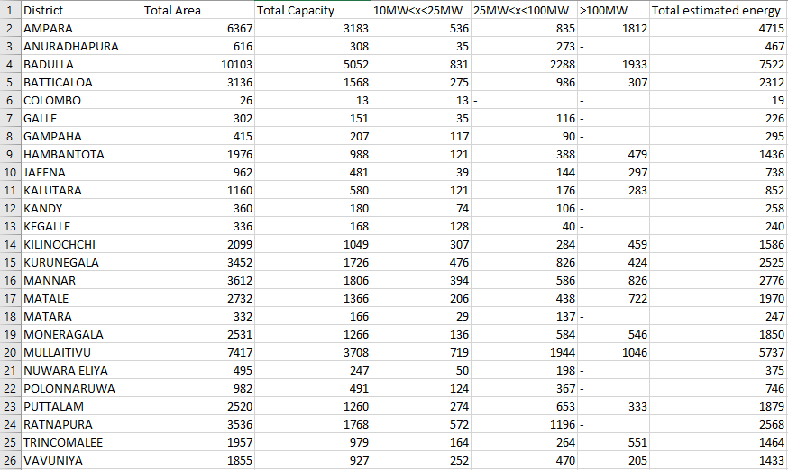

Figure ..sampledata set for question D

A data file named "SLSolaPowerLand_21_23.csv" was created by creating the data in Table 7.4. Here the district name, total area (hectares), total capacity (MW) and total estimated energy (GWh) are shown in a Sri Lankan district map. A map created using the information in the above data file is shown.

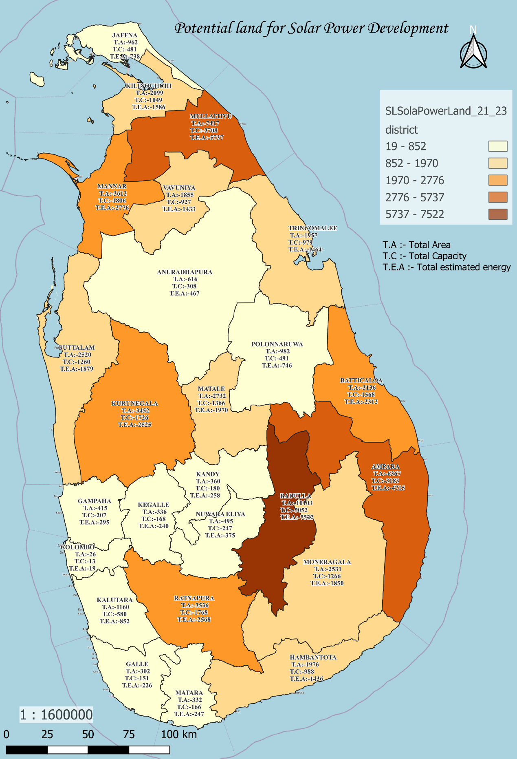

Figure ..Protential land for sola power development

Looking at the above map, the 25 focus districts are classified according to the total estimated energy that can be produced by solar energy. There, according to the estimated value, they have been divided into 5 sections and displayed in the respective districts on the map. That is, the estimated value is divided into sections such as 19-852,852-1970 etc. However, special colors have been given to the map for those sections. The values of the colors and sections thus used are given below.

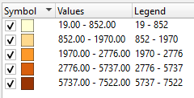

Figure ..Color pallet legend

As shown in this map, the districts with the highest total estimated energy content are shown in dark brown. That is, according to the data in the data file in Badulla district, it is noted that the highest total estimated energy is in Badulla district. Here, the total area in Badulla district is 10103ha and the total capacity of that area is 5052MW and according to the data, the total estimated energy is 7522GWh.

After Badulla district, the highest total estimated energy is in Mullaitivu and Ampara districts. However, Badulla district has relatively less suitable area in these two districts (7417ha, 6367ha). The total estimated strength of those two districts is slightly lower than that of Badulla district. However, when taken next, the total estimated energy of the districts of Mannar, Ratnapura, Kurunegala and Batticaloa shows a decrease.

However, when studying the map, the two districts of Anuradhapura and Polonnaruwa are popular among the people as the districts where the sun shines continuously. However, these two districts have the lowest total estimated energy in the map. For this, the suitable areas may have decreased due to the flooding (Drainage of Tanks) of the network during the seasons. However, the highest total estimated energy is contained in Ratnapura district where the work horizon is least for those are Among the districts with the least total estimated energy, Colombo district stands out as the best. 19 GWh of energy will be created in this district and this will be the least production in Sri Lanka. The production of 13 MW has been a reason. Among the districts that do not produce >100MW, all the districts at the bottom of the data file, such as Ratnapura, Polonnaruwa, Anuradhapura, Nuwara Eliya, etc., are included, and since Ratnapura district has 1196MW between 20MW<x<100MW, the total estimated energy of Ratnapura district is high.as.

Here, all the districts displayed in white contain the minimum total estimated strength. However, this same data file arranged in descending order is shown below.

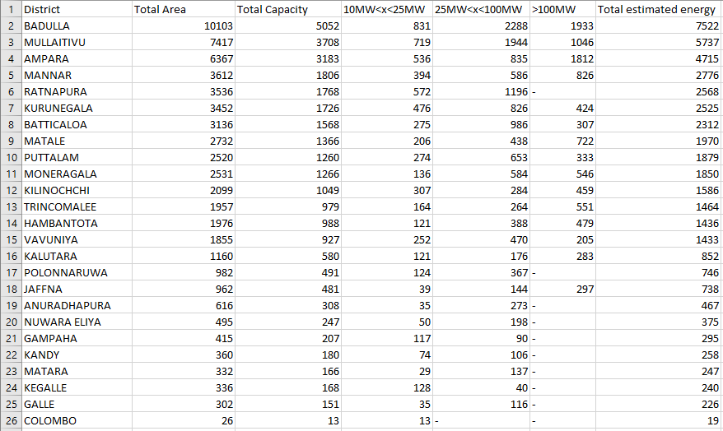

Figure .sampledata set for question D

# 

Today's world is focusing on renewable energy. The reason for that is the decrease in non-renewable energy sources like crude oil. However, even though the world pays attention to nuclear power, that energy is not suitable for small countries like Sri Lanka. Lack of sufficient space to build power plants seems to be a big reason. However, for the countries of Sri Lanka, among the renewable energies, Suraya power generation is the most appropriate.

There are several reasons why solar power is suitable for Sri Lanka. Here it can be seen that the sunlight that falls continuously throughout the year is a major factor. Also, a solar power plant in the Hambantota-Wellawaya area can be seen in the digitized area map below. Looking at the map, this solar power plant is located in a sparsely populated area, and as we all know, areas like Hambantota are areas where the sun shines most of the year. Here, according to the map, it seems that this area has been created with consideration for the ease of transportation and the area belonging to the forest.

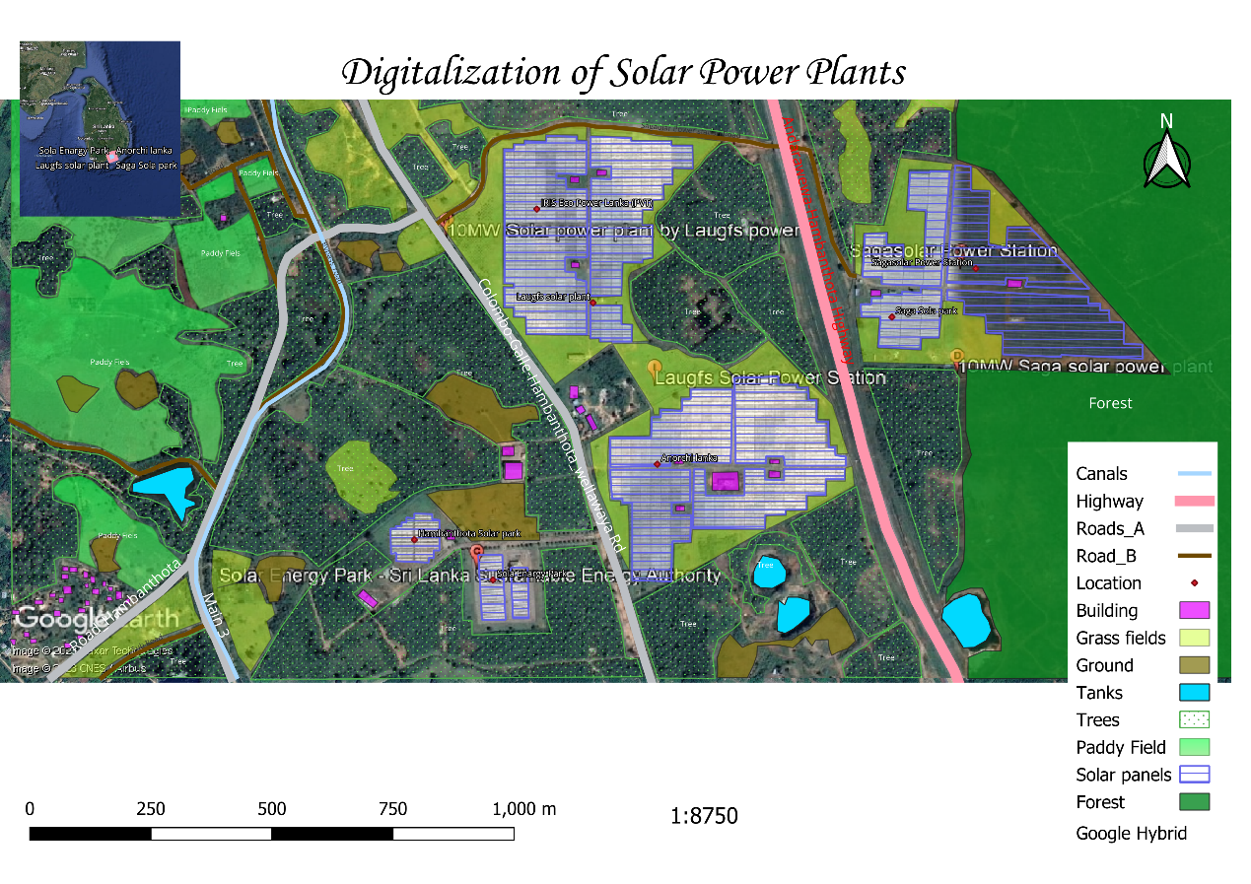

Figure ..Digitalization of solar power plant

Sri Lanka is known as a country that relies on hydropower for its electricity generation. During droughts, the process of hydropower generation stops. But during periods of drought, power cuts occur in the country. However, solar energy can be used as an alternative energy source. Then, in those times, the problems that may arise due to the creation of solar power plants in the areas filled with vacant land like the areas mentioned on the map will be minimized.

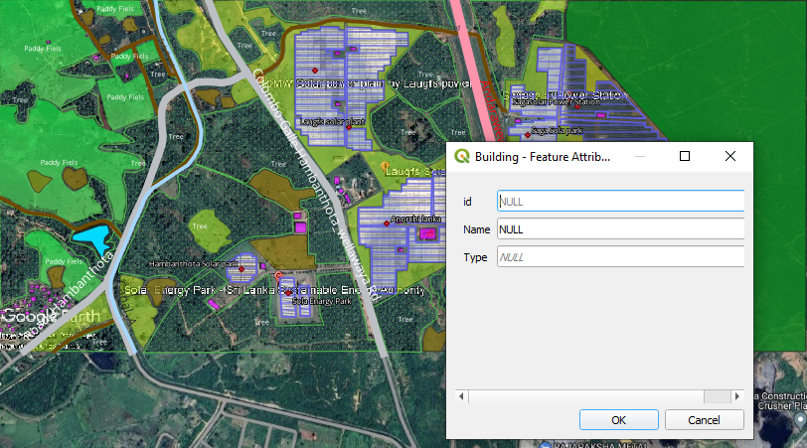In relation to each part of the map mentioned above, id, Name and Type parts are included as follows.

Figure ..Digitalization of solar power plant 2

# 

In this work, using the data provided in the "SLPetrolium-2023" database, a thematic map classified according to the number of sheds according to the districts will be prepared. To complete this task, I used PostgreSQL to perform tasks in the "SLPetrolium-2023" database. To create this database, the Table: 5-03: Descriptive Statistics on Monthly Gasoline and Diesel Usage Separately, available in page no 33 of "Disaggregation of Petroleum Product Usage by End User Category" released by Sri Lanka Sustainable Energy Authority of the report") was created.

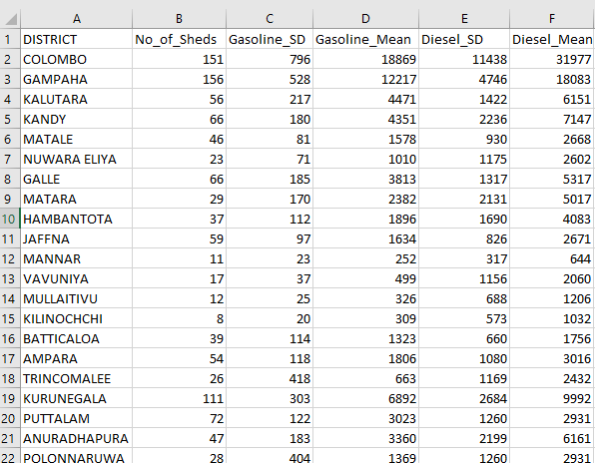CSV format is required to perform this task first. After getting the content table of the report, "SLPetrolium-2023.csv" was created using the "District code" data table with the assignment. Here DISTRICT, No_of_Sheds, Gasoline_SD, Gasoline_Mean, Diesel_SD, Diesel_Mean headers are included in the data file. Below is a screenshot of it.

Figure ..sampledata set for question E

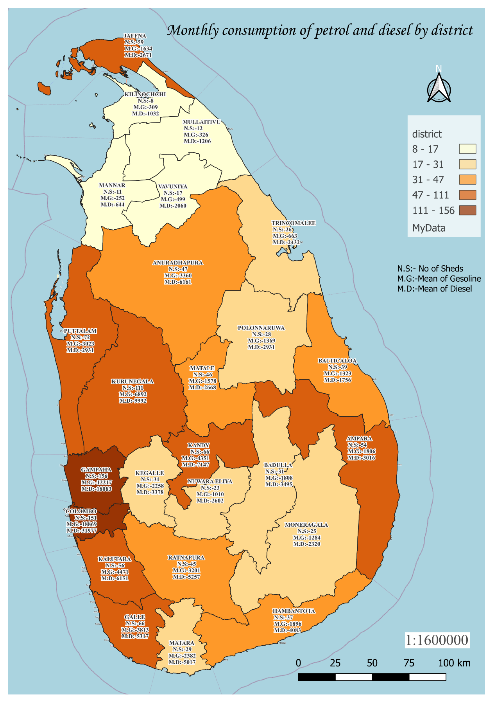

Figure ..monthly consumption of the gasoline and diesel by district

To understand all of the above, first we pay attention to the different colors for each district on the map. However, it is divided into districts based on the number of sheds located in that district.

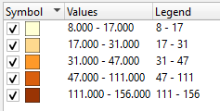

Figure ..Color pallet legend

Looking at this table, the districts are divided into 5 parts and mapped by sheds. Gampaha district has the highest number of sheds in one district at 156, but Colombo district has about 151 sheds, so that district also has the same color. However, attention can be drawn to a particular difference in the northern region of Sri Lanka. That is, the least number of sheds are in Mullaitivu, Vavnia, Kilinochchi districts(colorlib, 2023).

However, there is a difference in the Jaffna district because there are more sheds in the district compared to other districts in the Northern Plateau. There are 17 and 12 sheds in districts like Vavnia and Mullaitivu, but there are 59 sheds in Jaffna. The fact that Jaffna was the capital of the Northern Province was one of the reasons for this, while the population of the other regions was low.

However, an idea can be taken about the average usage of diesel and petrol according to each district using the map below. Similarly, in the district itself, the fuel consumption of diesel is comparable to that of petrol. This may be since the equipment used in Sri Lanka's transport system and other sectors are powered by diesel.

Also, this map shows information about the use of diesel in official color and the use of petrol in red color. Here a specific chart is shown in Puttalam district. The graphs show that the consumption of diesel and petrol is relatively similar. But in all the other districts, the above-mentioned diesel will be used more and more.

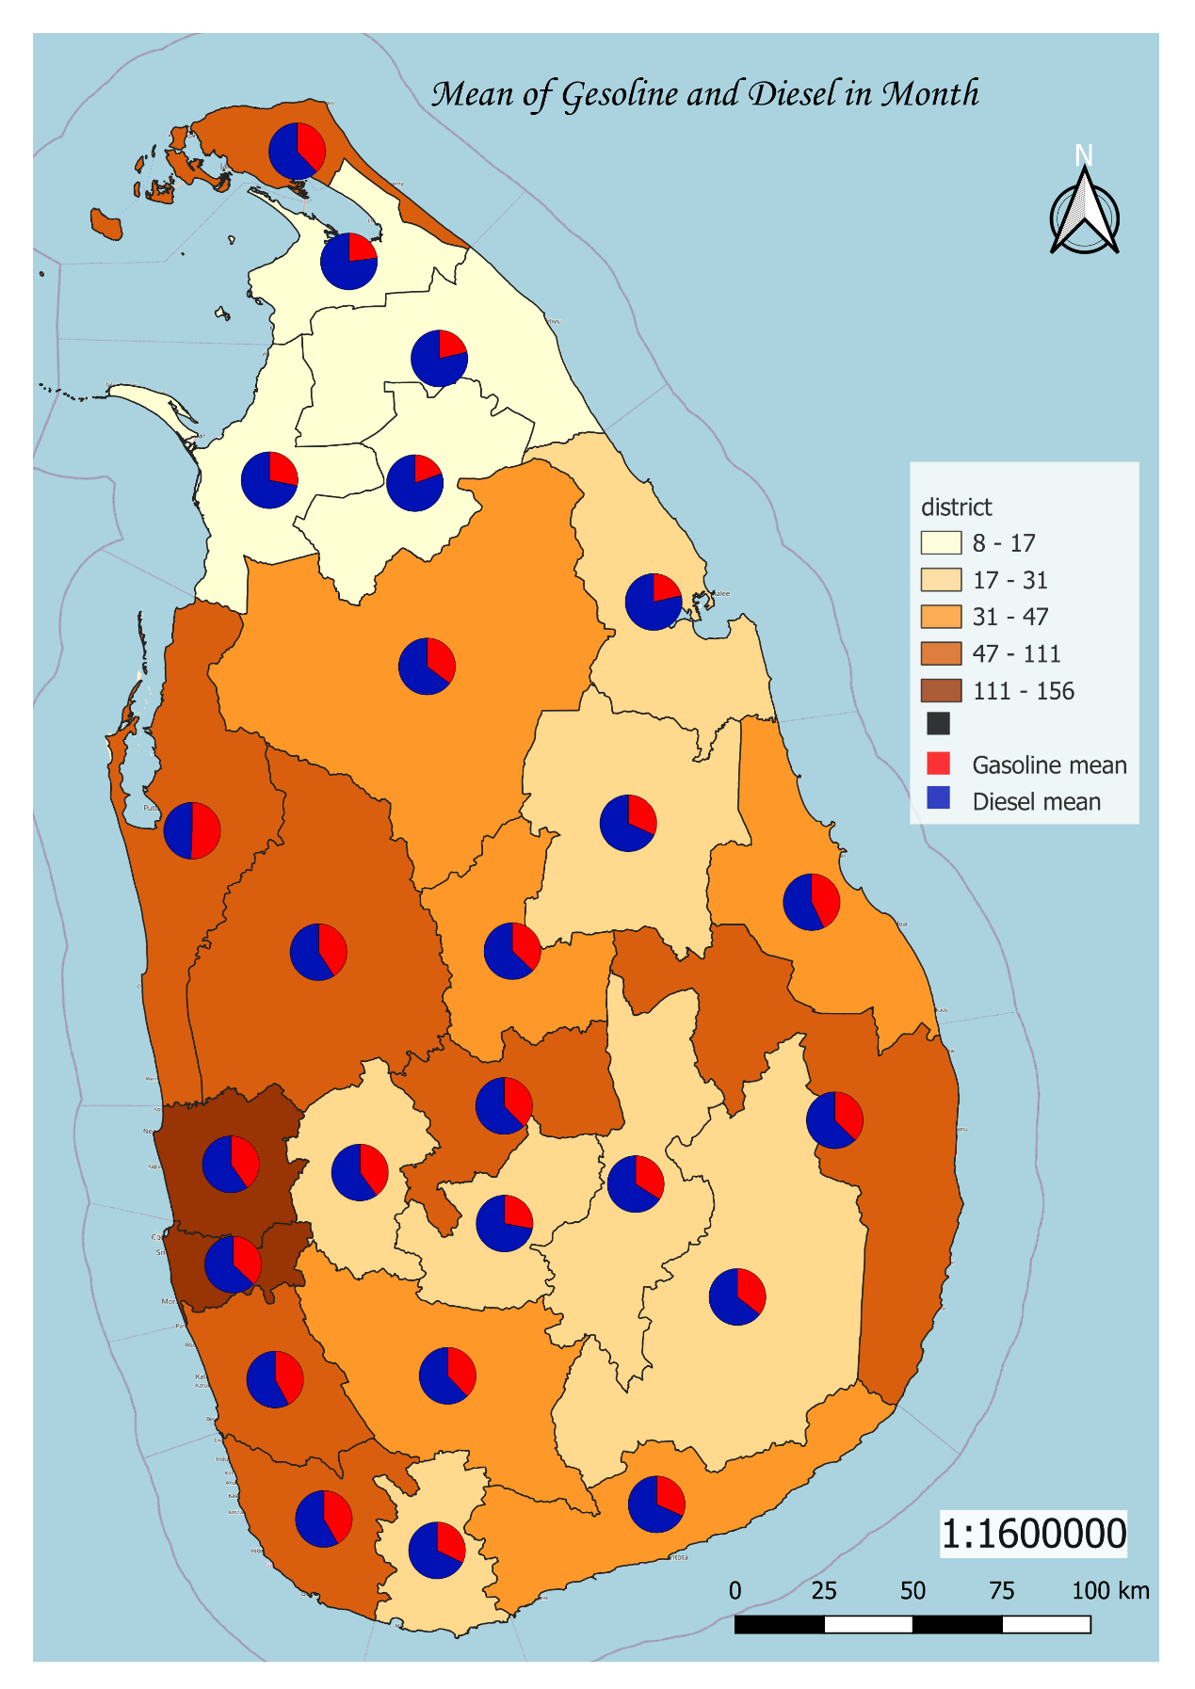

Figure ..Mean of gasoline and diesel in month using Pie chart

# 

In this task, suitable areas for renewable energy generation on the island are to be selected and mapped. However, to get the exact GPS locations of the areas identified by the Sri Lanka Solar Energy Authority, KML/KMZ files are created using Google Earth. Information such as latitude and longitude are then visualized on the location(colorlib, 2023).

Among renewable energies, wind power, solar power and biomass were mapped here. In studying the above problem C, Monaragala district has been mentioned as the most suitable district for wind power. Therefore, suitable areas are marked in Monaragala district. Here, during the construction of wind power plants, due to their excessive noise, an area without human settlements was first selected. However, those places are marked to be forested areas in Monaragala district. No matter how the marking is done on the top of the mountains, the ease of transportation for maintenance work has also been emphasized.

Mountainous areas as well as coastal areas are the most suitable areas for wind power generation. Here is a suitable record of the seashore listener in the areas of Puttalam, Hambantota, Jaffna. Also, the reservoir area has been mentioned as suitable areas for building power plants, where the area near Udawalawa reservoir is a suitable area for producing a power plant.

Badulla district has been mentioned as a district that has many suitable areas for creating solar power plants. Due to an area with mountains and valleys in the Badulla district, it is necessary to move to the top of the mountains to install these panels. The reason for this is because the light does not fall on properly on either sides of the mountain in the morning or in the evening. Hence, these are chosen to be installed in the pits at higher places.

Also, in the areas with reservoirs near the tanks, it is reserved for installation. However, several places along the canals have been mentioned as suitable places. Here in Mullaitivu, the areas where the sun shines for most of the year. It is possible to build solar power plants easily as there are few tall trees here. Because having tall trees to build in protected forests is expensive and causes environmental damage. Also, the areas with high population are not suitable because the space is minimal.

However, many areas in Monaragala district have been mentioned as suitable areas for creating biomass. In addition, there are suitable places for biomass production in Vavuniya District and Hambantota District. However, the suitable areas for renewable energy production in Sri Lanka are displayed separately in the map and thus a good overview can be obtained.

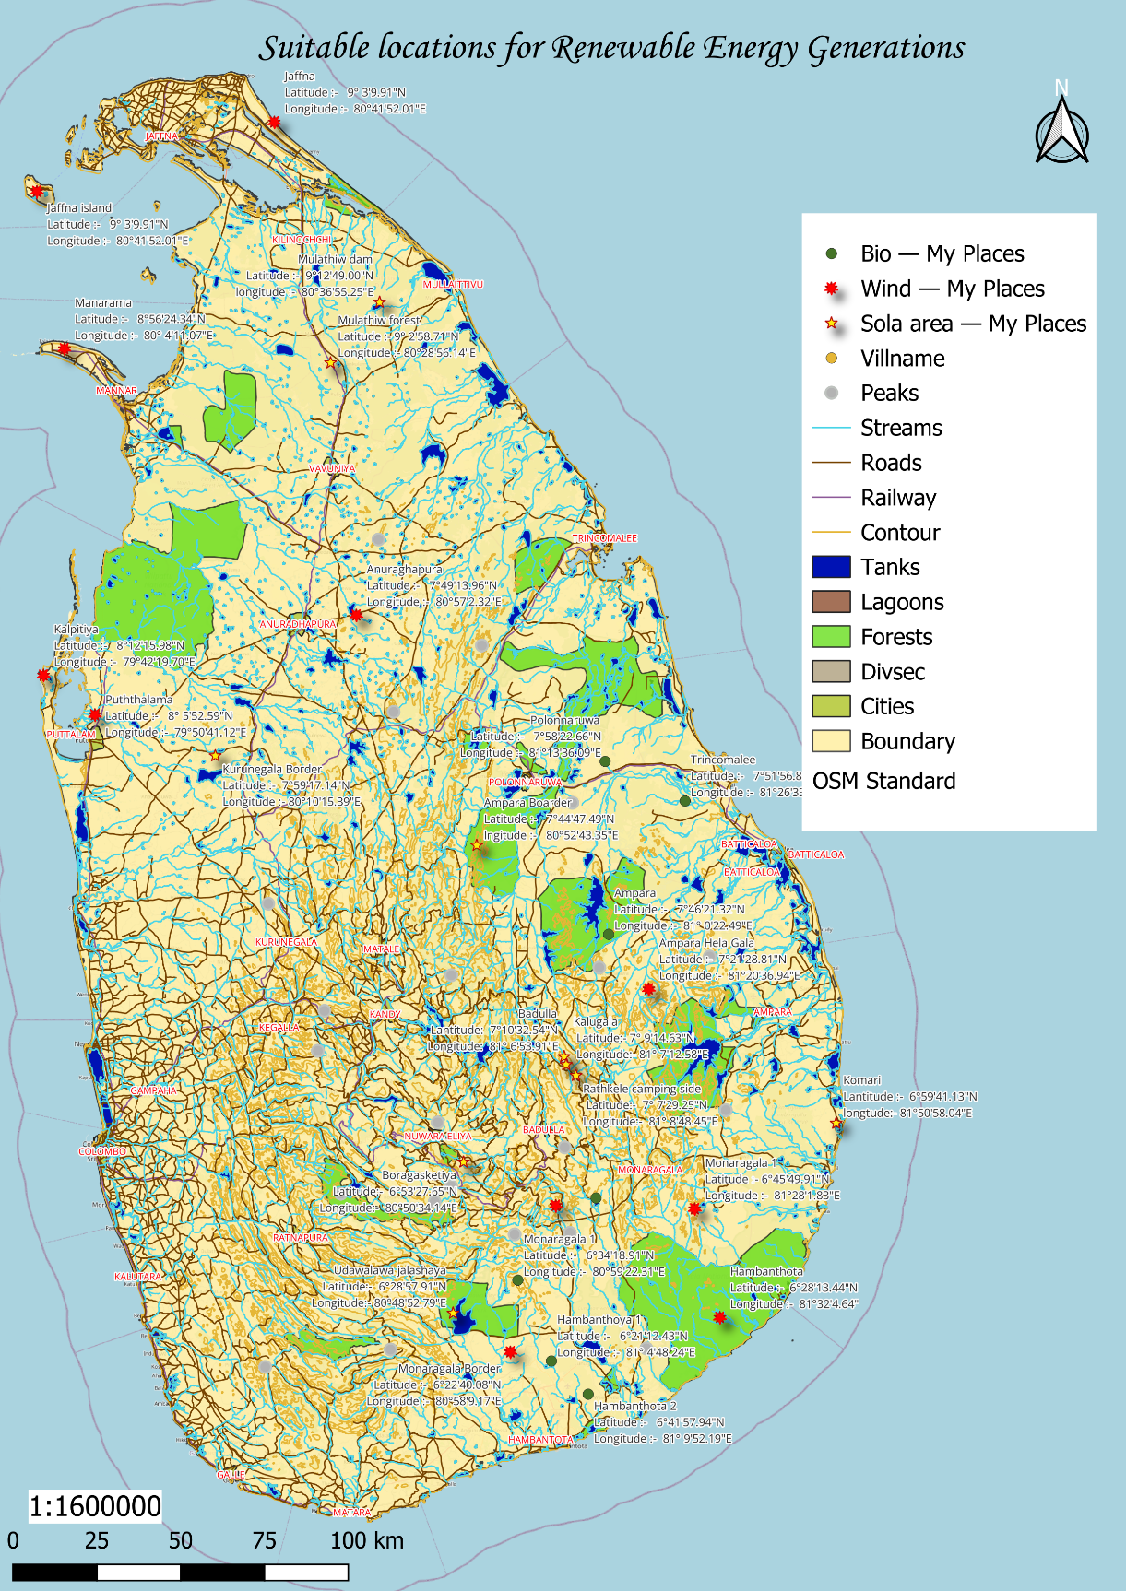

Figure ..Suitable location for renewable energy generation

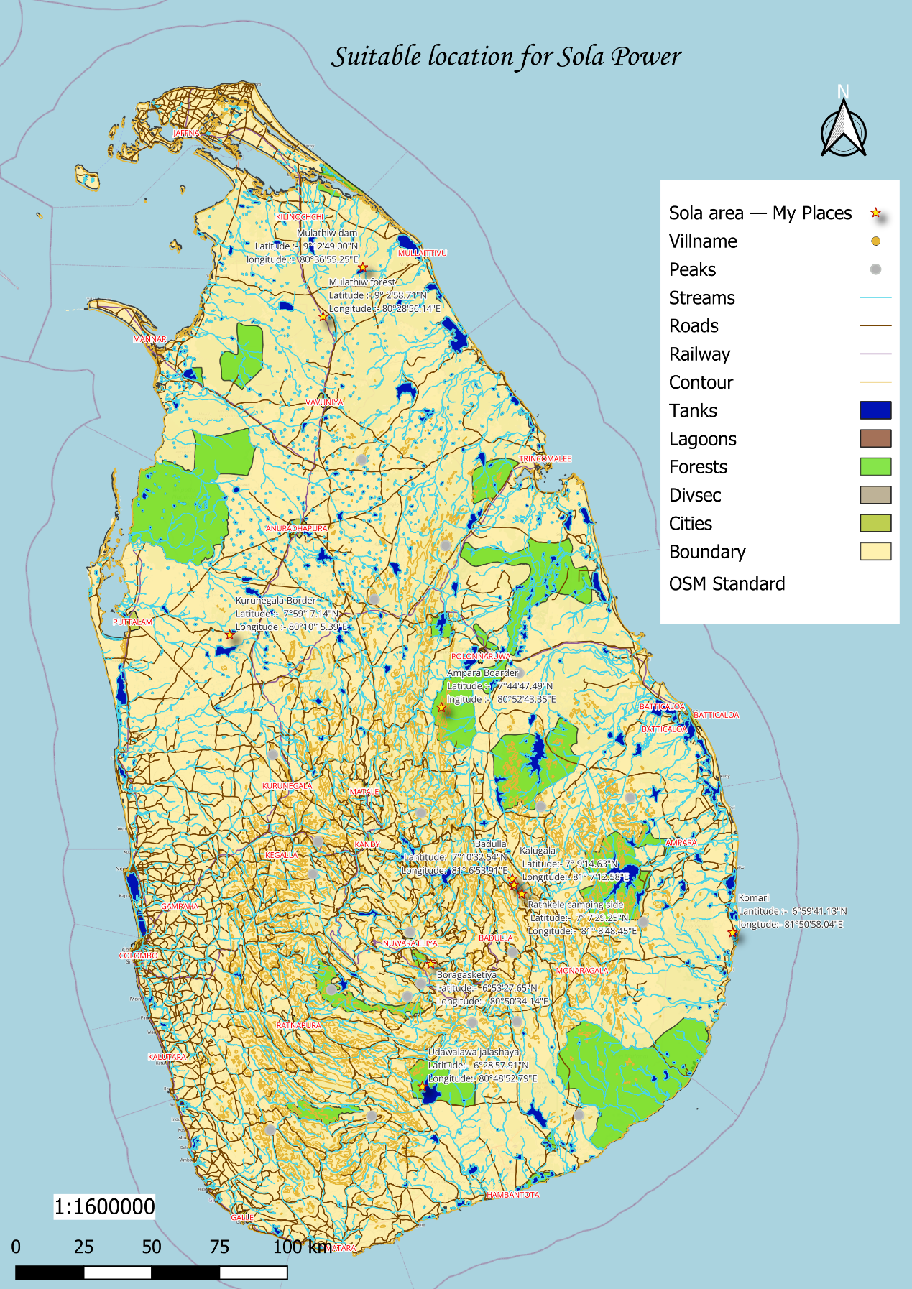

Figure ..Suitable locations for sola power

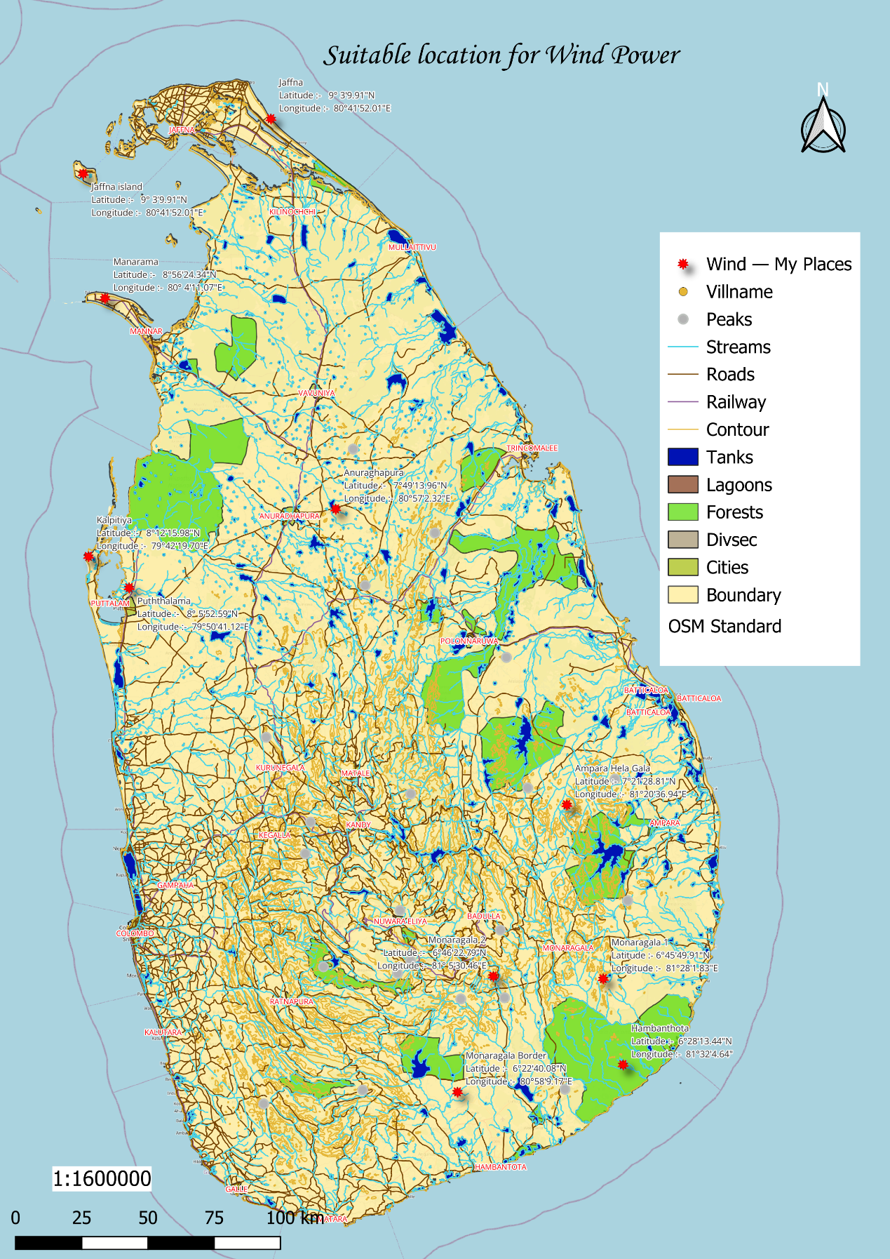

Figure ..Suitable location for wind power

# 

In this work, a map has to be prepared to find suitable land for the newly developed regional research center for renewable energy. However, there are several requirements to be met when searching for this land. There should be a 500m distance to Uruwala Primary School as a basic requirement. Also, it is unclear that 600m to the Industrial Development Center and 700m to the Jayathilaka Hall should be within a two-day walk.

While creating this map, the respective locations are buffered according to the required distances. There the respective place was taken as the center and the necessary distance was taken as the radius of the circle and the circles were created. Then the area common to all those areas was selected and reserved as the most suitable area for this purpose.

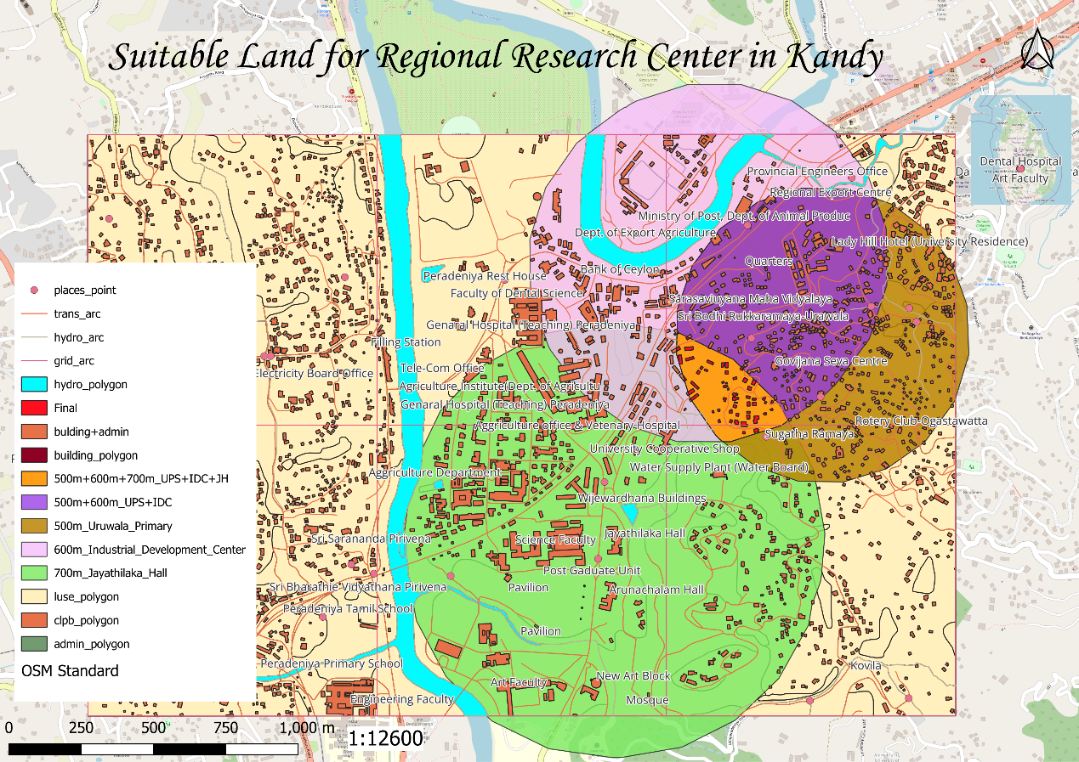

Figure ..Suitable land for Regional research center in Kandy

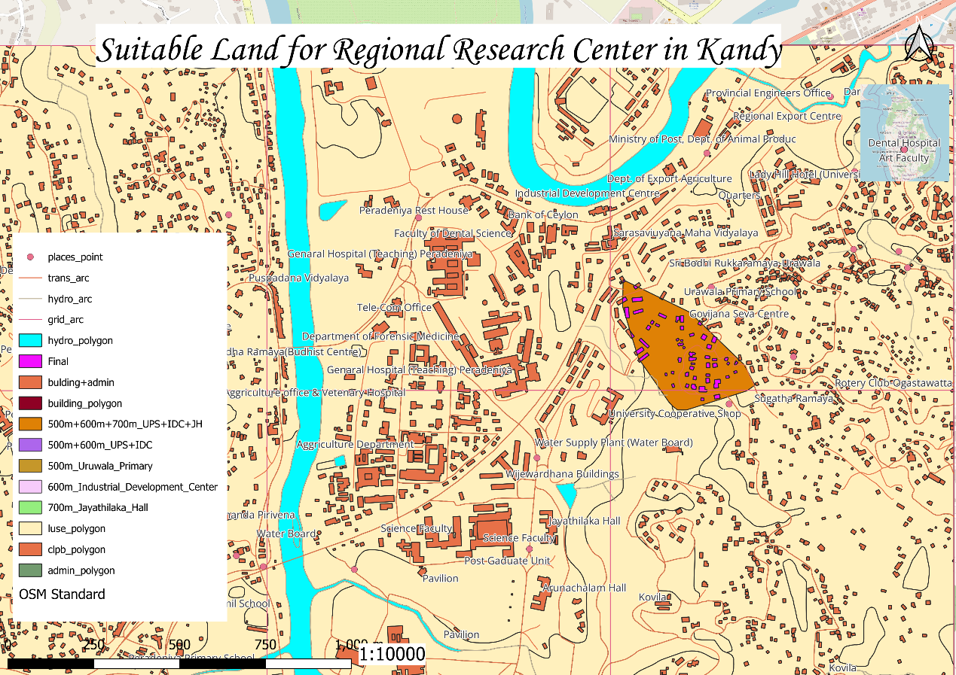

Figure ..Suitable land for Regional research center in Kandy

The map above shows the suitable land in orange color. However, considering this area, it is a piece of land with 55 buildings in this area. Here the buildings in the area are shown in purple.

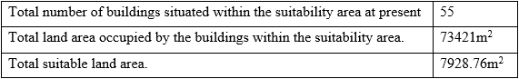

Table ..Answer table for area

A regional research center for renewable energy consists of 55 buildings to find suitable land for new development. Also, the total area occupied by buildings in the suitability area is 73421m2 and the total suitable area is 7928.76m2. However, even within this suitable area, there may be areas unsuitable for building due to the presence of trees. It is also unsuitable for construction in steep areas. However, less space will be available for construction of buildings today.

# CONCLUTION

This paper pioneered renewable and non-renewable energy. Here we will consider what should be done to maintain the cooling of a building during construction. There, by maintaining the cooling, the power is saved by using the energy to a minimum. Also, by analyzing the information by Mary R-Studio, errors were made(colorlib, 2023).

Postgres SQL, Google Pro and QGIS software are used to solve other problems here. The primary objective here is to redevelop non-renewable energy. There, suitable area mapping for Sulan power plants in Sri Lanka will be done. Also, according to the energy produced by Suraya power plants, their spread across the country at the district level was also recorded. Also, a mapping of fuel consumption and the extent of petrol stations in Sri Lanka is done here.

Here, suitable areas for re-establishment of renewable energy are also marked. Here, suitable land for solar power plants and suitable land for solar power plants are marked on a map of Sri Lanka. Also, a suitable amount of land for the research center in the Kandy area is being used and digitization was done in relation to a part of the map that has been provided.

# GANTT CHART

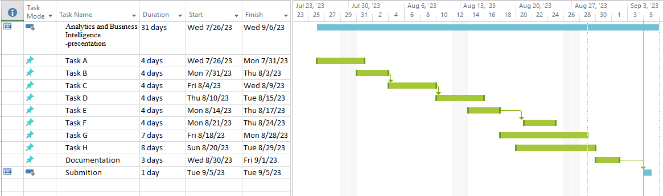

# REFERENCERS

colorlib, 2023. *Home*. [online] Available at: <https://www.energy.gov.lk/index.php/en/> [Accessed 5 September 2023].

Rodrigo, D.A., 2022. Renewable Energy Resource Development Plan 2021-2026.

# APENDIX

**Appendix C**

Below are some screenshots taken while solving problem C.

* **Labeling the district.**

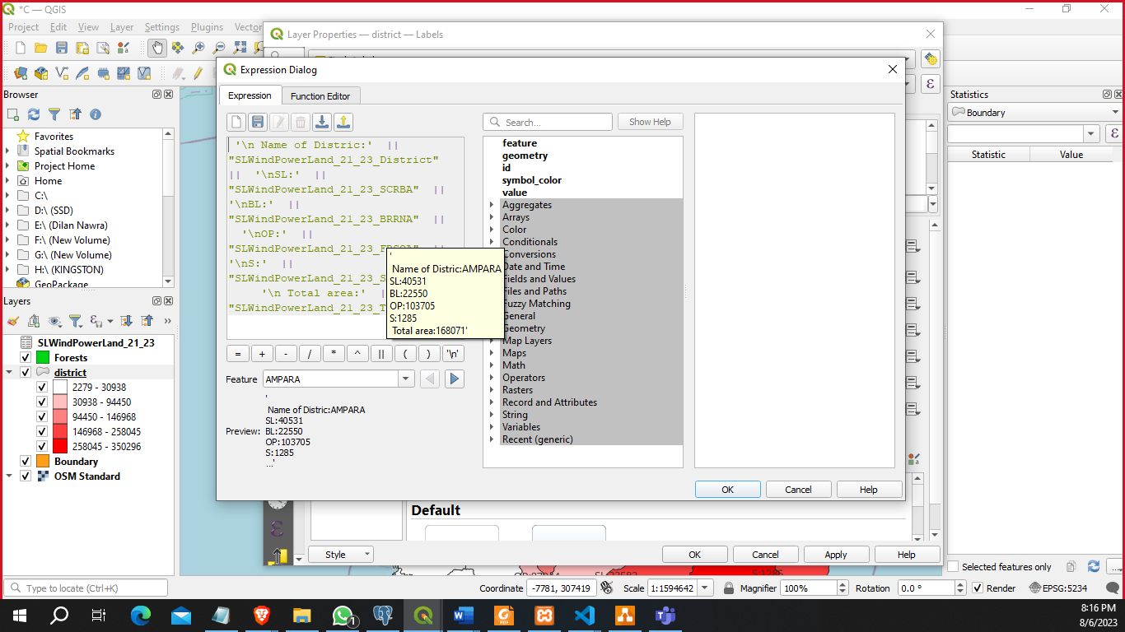

* **Ready to apply print view.**

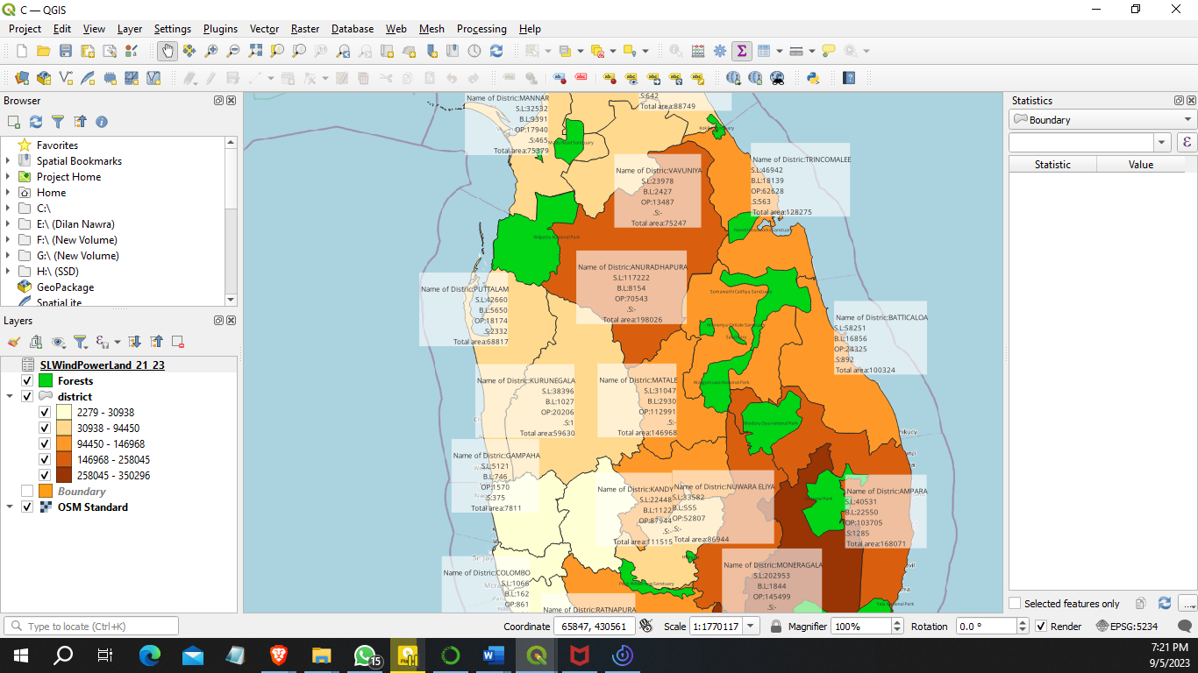

**Appendix D**

Below are some screenshots taken while solving problem D.

* **Ready to apply print view.**

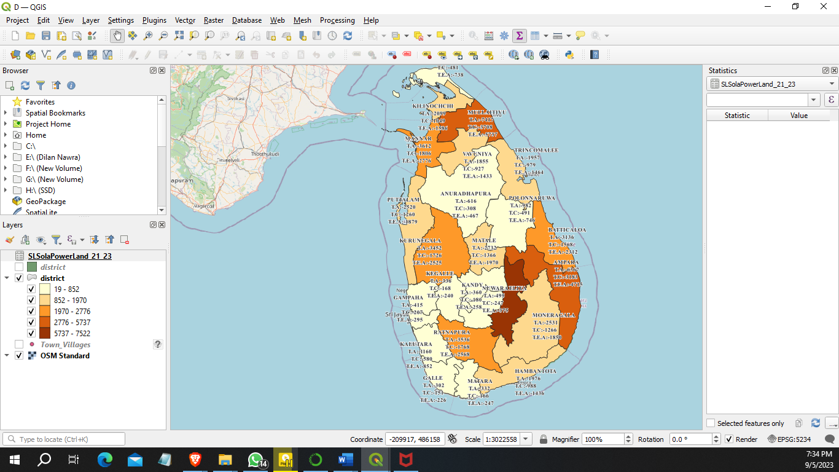

* **Attribute table**

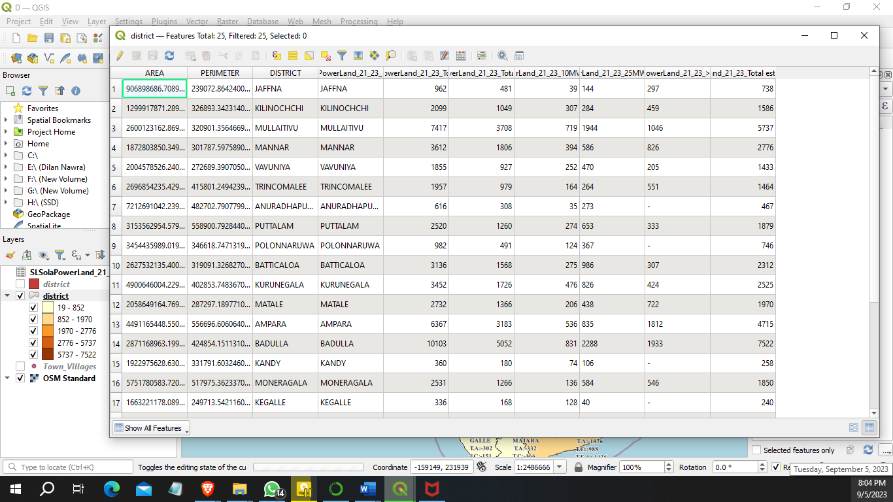

**Appendix E**

Below are some screenshots taken while solving problem E.

* **Set the picture in the OSM map.**

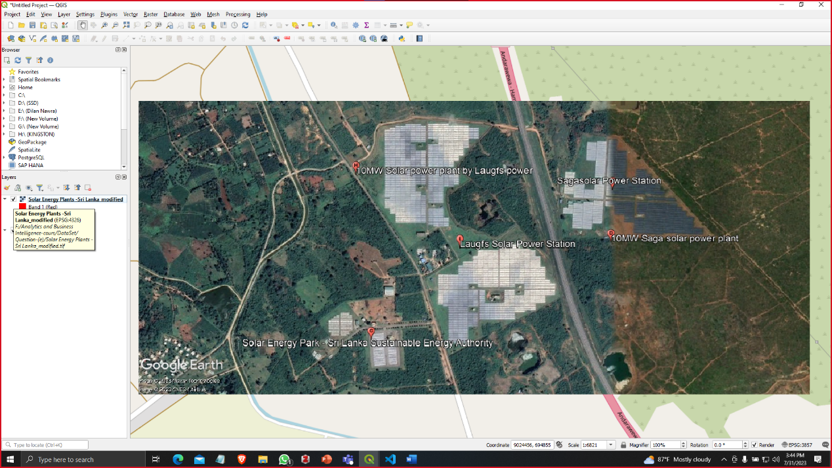

* **Digitalize the Highway**

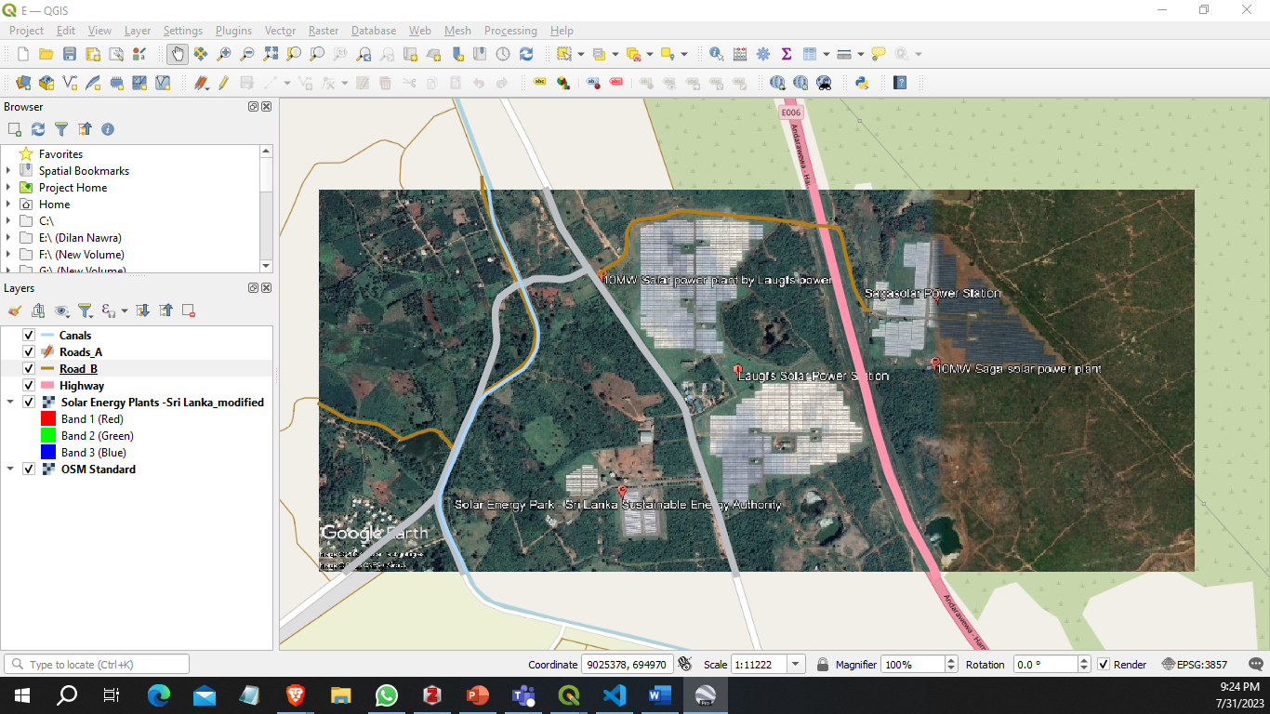

* **Digitalize the forest.**

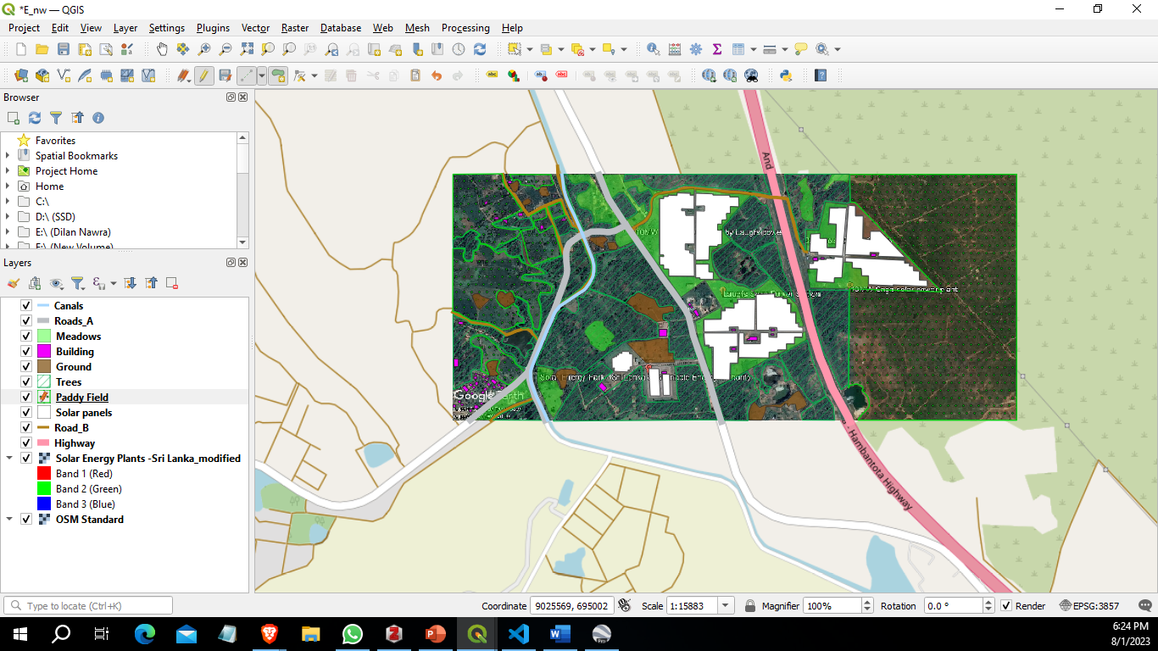

* **Label the locations.**

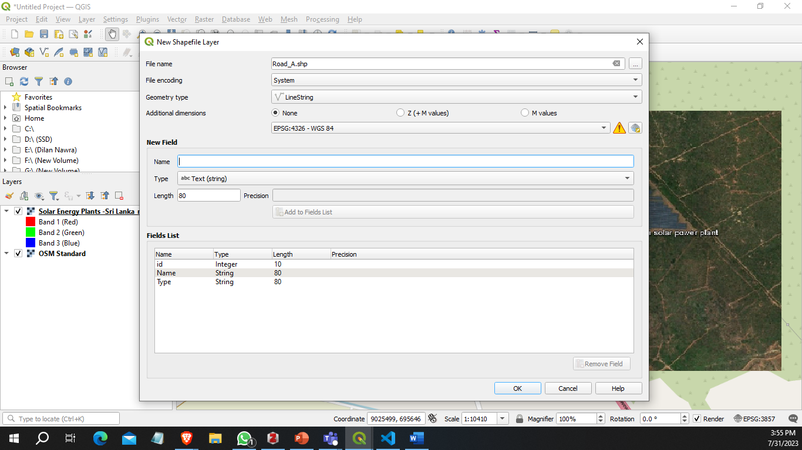

* **Ready to apply print view.**

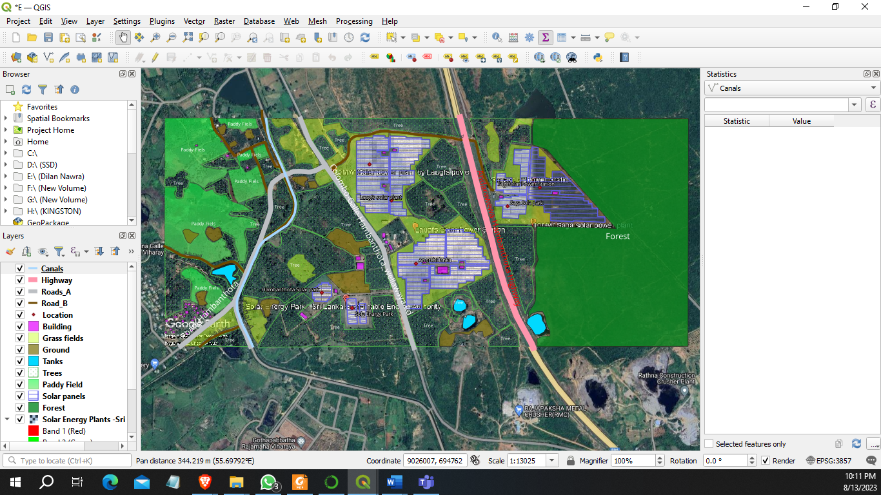

**Appendix F**

Below are some screenshots taken while solving problem F.

* **Crete table and insert table in pgAdmin.**

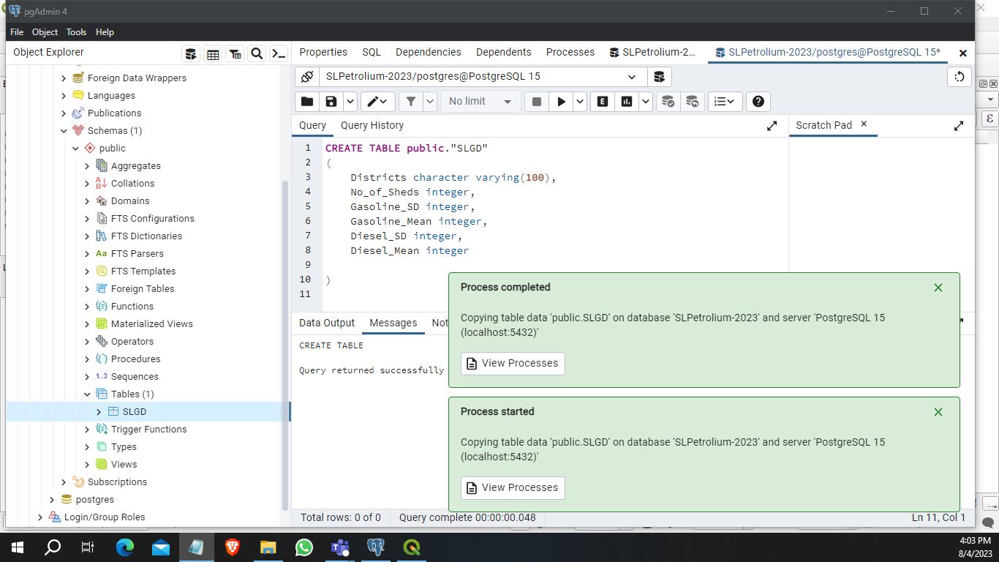

* **Showing the data**

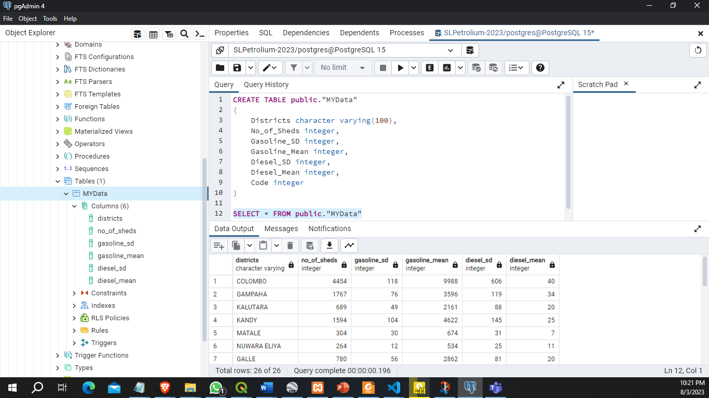

* **Connecting the pgAdmin**

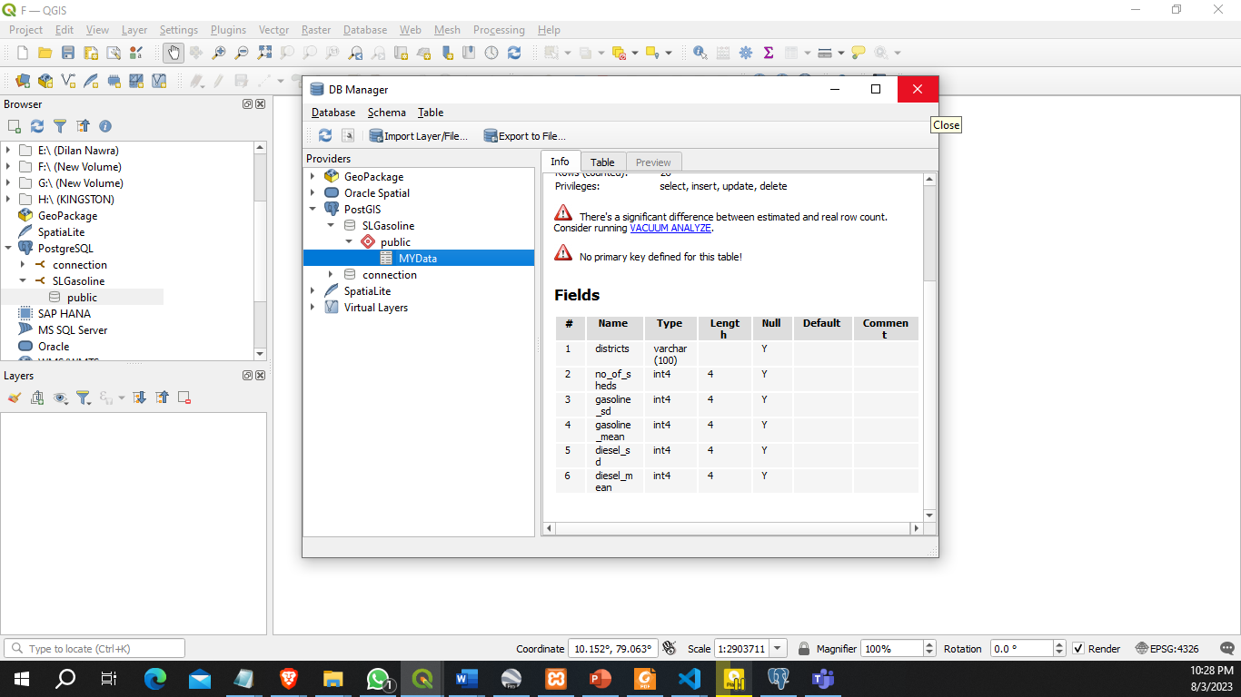

* **Connecting the table**

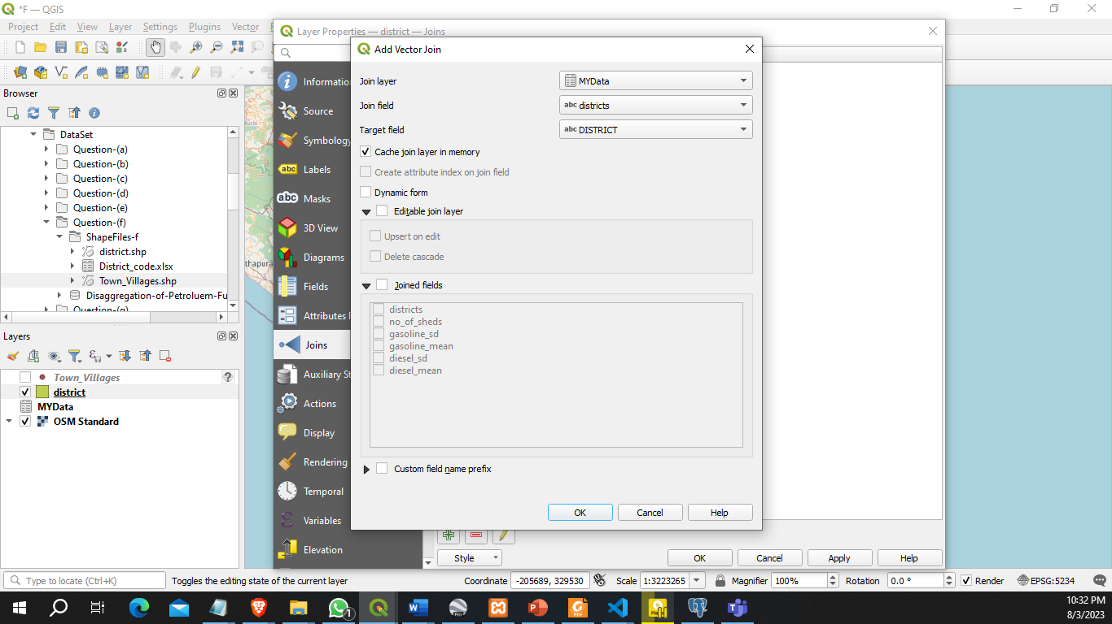

* **Ready to apply print view.**

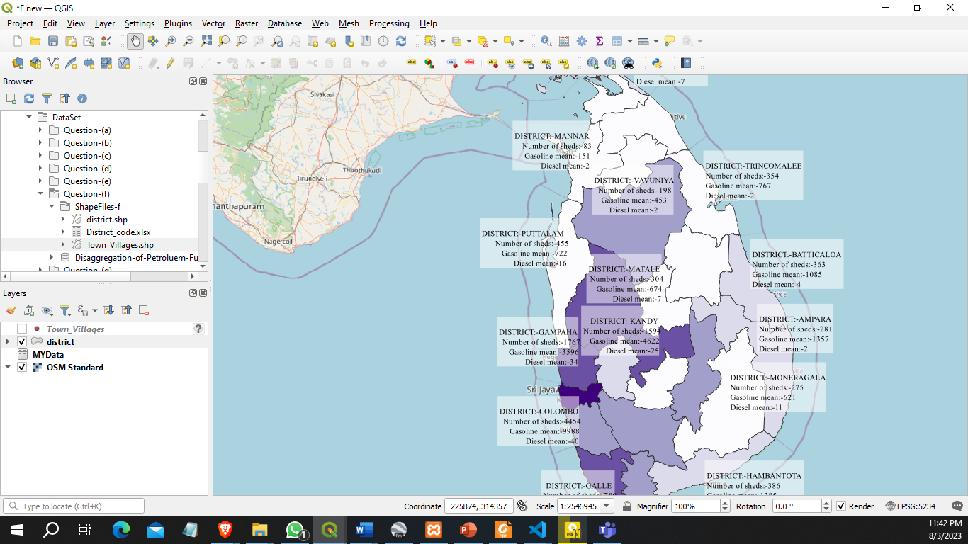

**Appendix G**

Below are some screenshots taken while solving problem G.

* **Create the shape file.**

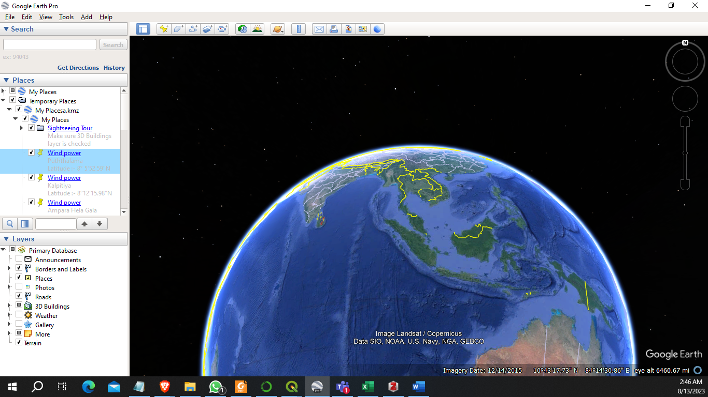

* **Pin the point on map.**

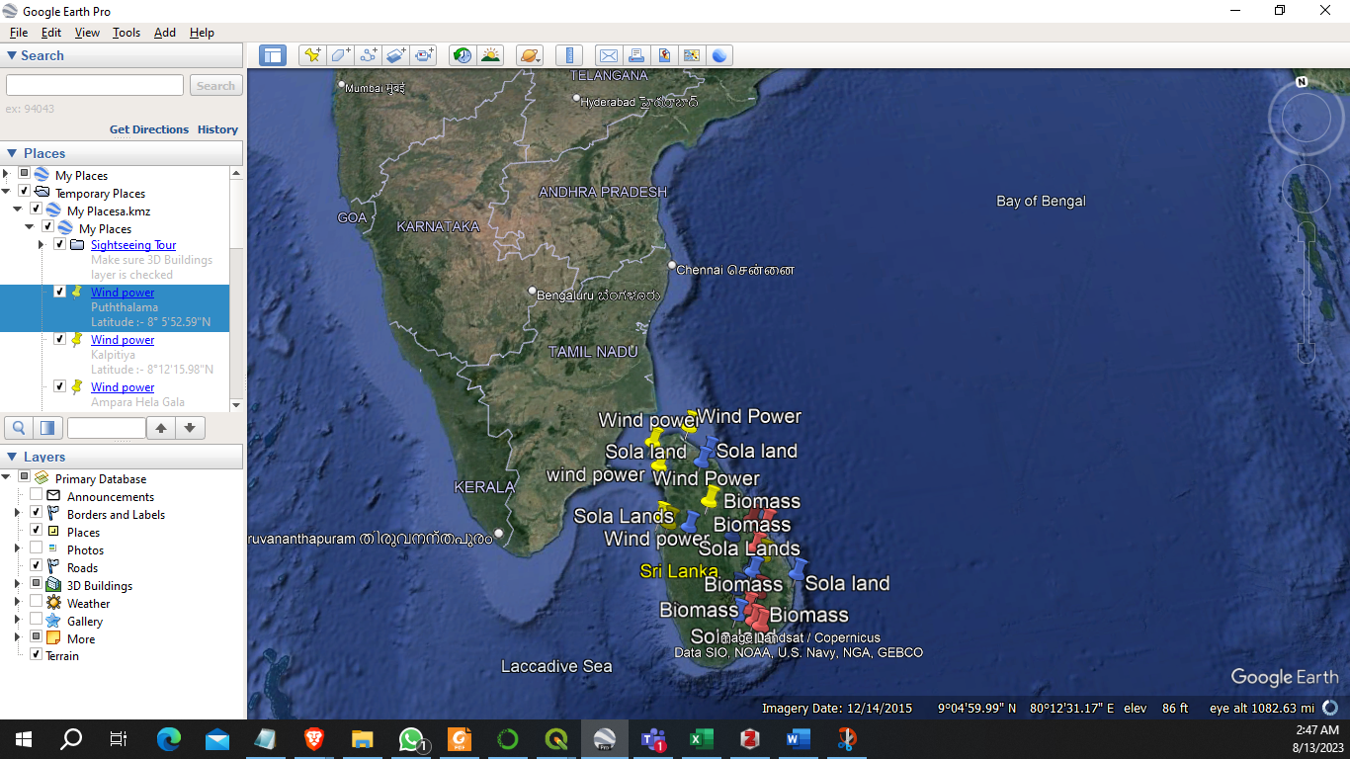

* **Created shape files.**

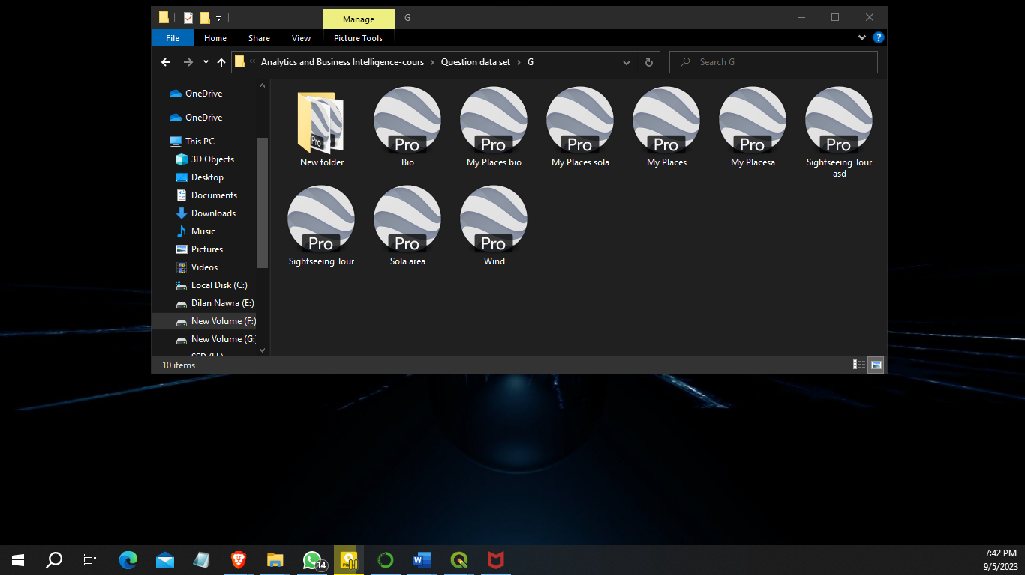

* **Ready to apply print view.**

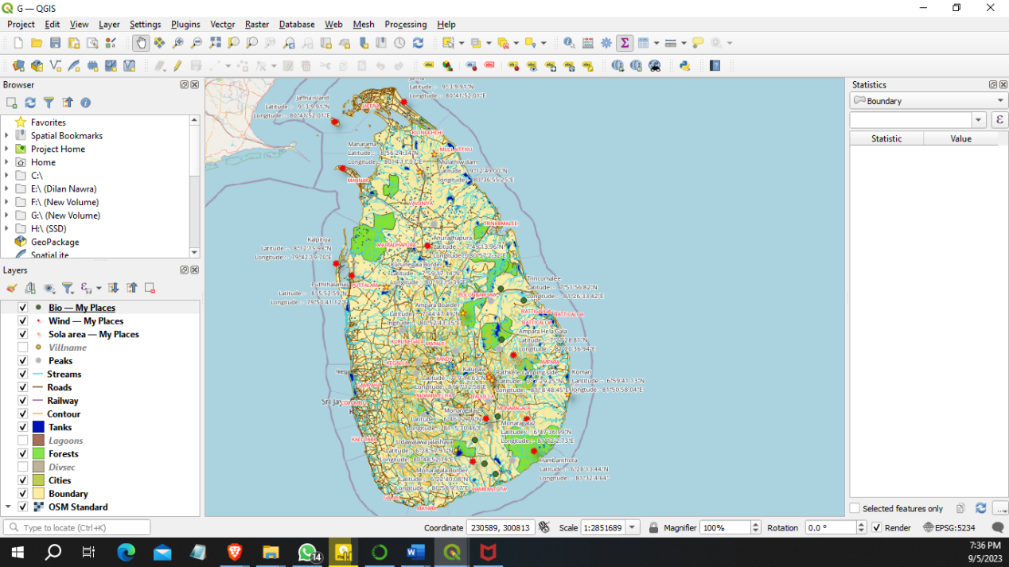

**Appendix H**

Below are some screenshots taken while solving problem H.

* **Insert the shape files.**

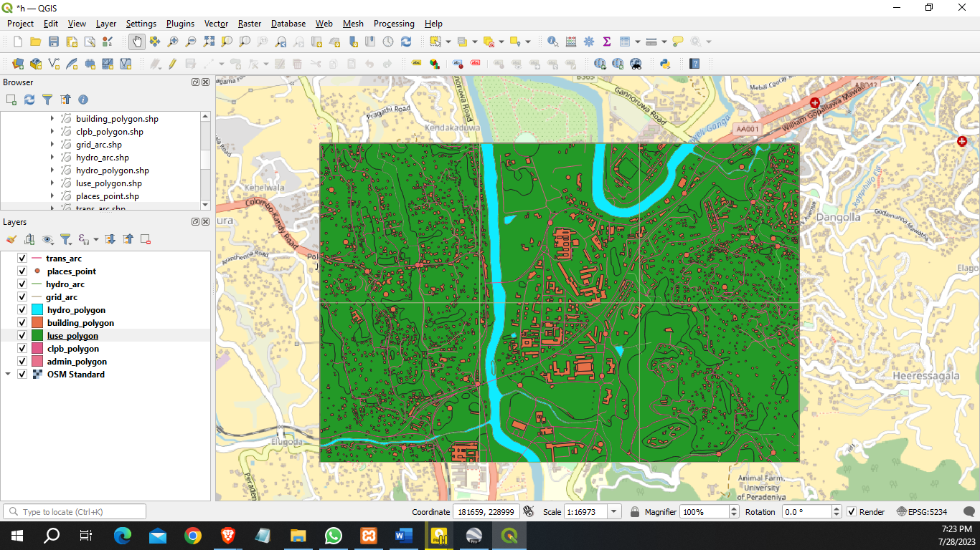

* **Buff the location area.**

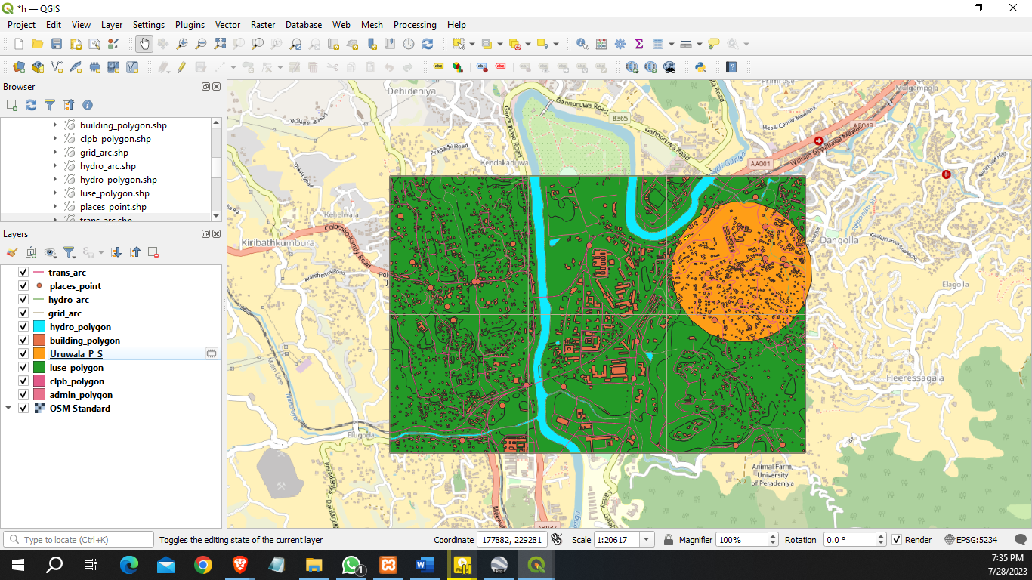

* **Buff the 3 location areas.**

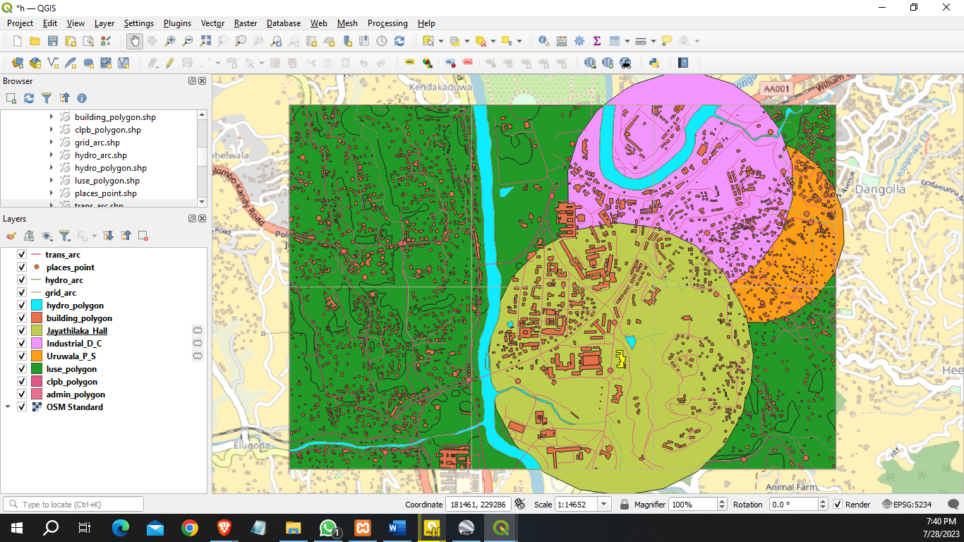

* **Get to the suitable area.**

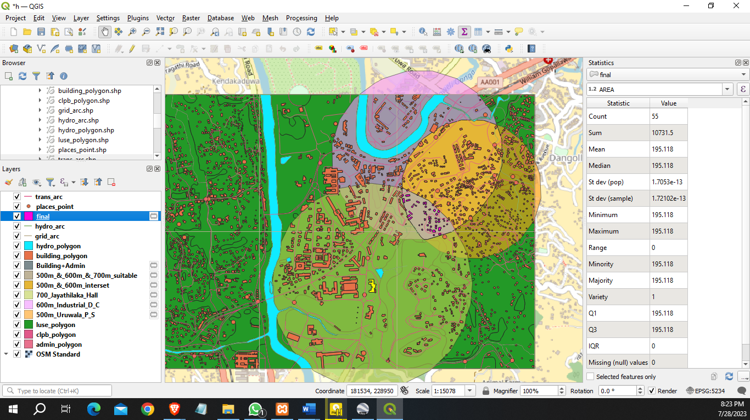

* **Ready to apply print view.**

